Kirkby-in-Malhamdale United (VA) Primary School,

Kirkby Malham,

Skipton,

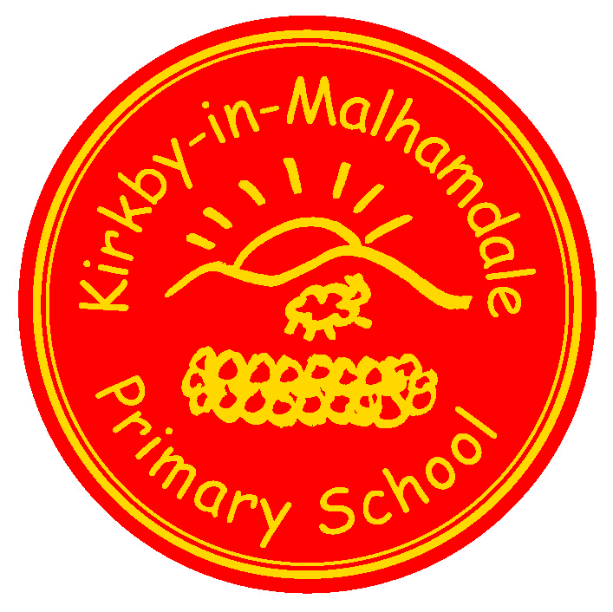
North Yorkshire,

BD23 4BY.

Telephone and Fax: 01729 830214
e-mail: admin@kim.n-yorks.sch.uk

Executive Headteacher: Mr Richard Wright

NEWSLETTER Autumn 1 – 13th September 2018

Welcome Back to school to all children and parents. I hope you had an enjoyable summer holiday. The children are all in great spirits and have come back full of enthusiasm. We look forward to a busy yet exciting term. There will be lots of new opportunities for the children as we embark on our collaboration and work closely with our partner school Settle Primary School. Exciting times ahead!
Johnny Walker Rugby Festival–Friday the 21st September Y3,4,5 and 6 will be going to Settle Primary School to take part in the Johnny Walker rugby tournament organised by Mr Wright. The children will be out the whole day, details will follow.
Accordion – Mr Harry Hinchcliffe delivered an assembly last week all about the accordion. He will be delivering a workshop to all children about how to play the accordion. After this your child will come home with some information if they would like to learn to play this instrument.
Awesome Owls – Starts this Monday 17th September as planned and promises to be an amazing new resource for the school. However it does require there to be the right kind of demand for this service from parents if it to truly reach its potential. Use it or lose it. Give it a try - we will offer pay as you go sessions to parents. But the club must be booked the morning of use if you are to do this which means forms are returned to the school. If the registration forms aren’t used then the people working at the club do not have your details. So please register if you wish to use our after school club service.
Start of the School Day – please be aware that school does not open until 8.45 am every morning.
Children dropped off before this time are the parents responsibility until a member of staff is on the playground at 8.45 am – thank you.
Parking – thank you for your continued help with this at the start and end of the day. The bus needs to get as close to the gate as possible to collect the children safely.
Headlice – please check your child’s hair for headlice please. Treat the whole family if found.
Nuts – please be aware that we are a nut free school. Snacks that children in KS2 bring into school must only be fruit and vegetables, no cereal bars etc. Many thanks for your help with this.

Cross Country – This takes place on Tuesday 18th September at 1.00 pm. We wish all our runners in this event all the best. We have checked with Ingleton Primary and unfortunately parents cannot come to watch this event.
Open days – Settle College Open Day and Evening – Thursday 27th September
The Skipton Academy Open Event, Wednesday 26th 6pm-8.30pm Open mornings 24th,25th and 26th to see the school in action (ring for an appointment)
Flu jabs – an email was sent out about Flu jabs for FS-Y5, please could you go online to register if this is relevant to you.
Book Club Class 1 – Book Club will be starting again on Monday 17th September from 3.00pm – 3.30pm – everyone welcome.
Parent Pay – Thank you to all those who have paid for their child’s lunches so far, please keep checking your ParentPay lunch account for KS2 children If your child has been to ASC for the first two weeks of term I will put it on your account but from Monday onwards Awesome Owls take over and you will be paying directly to them. If your child is having milk this will be on ParentPay too.
Governors – please look on our school website on the Governor section to familiarise yourselves with our school's Governing Body. We have also created a new PTA page, which is under the Parents tab on the top task bar on the website too.

Diary Dates
Sat 15th Sept | Ermysteds Grammar School – 2nd Selection Test
Tuesday 18th Sept | 9.30 – 11.30 Howard Bullock Dance (all term)  1.00 pm North Craven Cross Country for Y3/4/5/6 (voluntary, any more slips to be returned by Friday 14th Sept)
Wed 19th Sept | Recorder Club with Mrs Ellis (all term)
Thurs 20th Sept | Accordion Workshop with Mr Hinchcliffe
Sat 29th Sept | SGHS Selection Test
Fri 12th Oct | Am – Rec – Y5 flu vaccinations
School Uniform – We have been informed by our suppliers MC Sports that uniform is available to order online at http://www.mcsports.org.uk/kirkby-malham-primary-school/
You can also ring Mike on 01756 791688 or email him at mcsportsonline@gmail.com
GDPR – Privacy Notice for Parents and Pupils
The latest Privacy Notice for Parents and Pupils can be seen on our school’s website under Statutory Information
Safeguarding Notice
Kirkby-in-Malhamdale United V.A Primary School is committed to ensuring the welfare and safety of all children in school. All North Yorkshire schools, including Kirkby-in-Malhamdale Primary School, follow the North Yorkshire Safeguarding Children Board procedures. The school will, in most circumstances, endeavour to discuss all concerns with parents about their child/ren. However, there may be exceptional circumstances when the school will discuss concerns with Social Care and/or the Police without parental knowledge (in accordance with Child Protection procedures). The school will, of course always aim to maintain a positive relationship with all parents. The school’s child protection policy is available in the policies section of the web site.

