Kirkby-in-Malhamdale United (VA) Primary School,

Kirkby Malham,

Skipton,

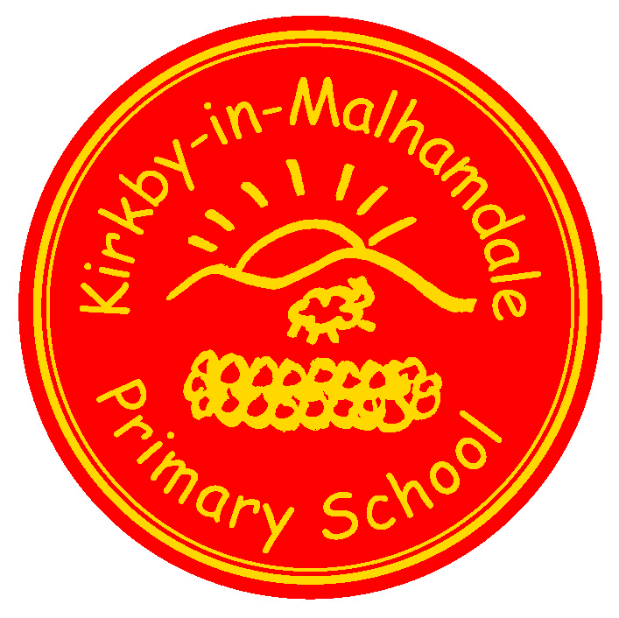
North Yorkshire,

BD23 4BY.

Telephone and Fax: 01729 830214
e-mail: admin@kim.n-yorks.sch.uk

Executive Headteacher: Mr Richard Wright

NEWSLETTER Autumn 3– 11th October 2018

n
 | Certificates - General Achievement and Writer of the Week
Class 1 | James, Harriet
Class 2 | Edward, Lucy
Class 3 | Carys, Thomas, Emily

Captain’s Table - Edward, Thomas C, James E, Violet, Anna, Alice, Carys, Jacob, Betsy
Well done to all the children who have been recognised for their hard work and effort in all areas in the last two weeks – keep it up!
Craven Cross Country – Anna writes ‘On Tuesday me, Alice, Harry E Fraiser, Frank, Tyler went to Giggleswick for the cross country. It was a lovely day to run. We ran around the rugby field and then the rocky running path. Fraiser, Frank and Tyler ran really well too. Fraiser was 7th and Frank was 19th, Tyler was 25th boy. Alice, Harry, Hance and I got through to Dalby Forest for the county competitions final’
This is a remarkable achievement, well done to those four and good luck at Dalby Forest in March 2019 – Mrs Allen x

Forest School an Outdoor Classroom
This term we are hoping to develop a Forest School with an outdoor classroom.
We are aiming to up-cycle materials to help to create this exciting learning environment.
Here comes the ‘Big Ask’...do any parents have any spare wooden pallets, or sleepers, that we could use to up-cycle into paths, furniture and/or shelters. We would also love any tree trunk sections large enough to make outdoor classroom seats and old metal pots and pans to make hanging musical instruments. If so, could you be kind enough to deliver them to school and we will move them to our designated Forest School area. Exciting project! Thanking you in anticipation!

City of Sanctuary at KM Church – Flynn writes ‘Last Friday evening me and Alfie, Rafe, Oliver, Matthew, Joshua, Anna, Mia and Betsy went to church to greet the nice ladies and children from Leeds. They came to stay with families in Malhamdale. They came for a holiday to enjoy the countryside and our beautiful scenery. It was nice to see them smiling and enjoying themselves’

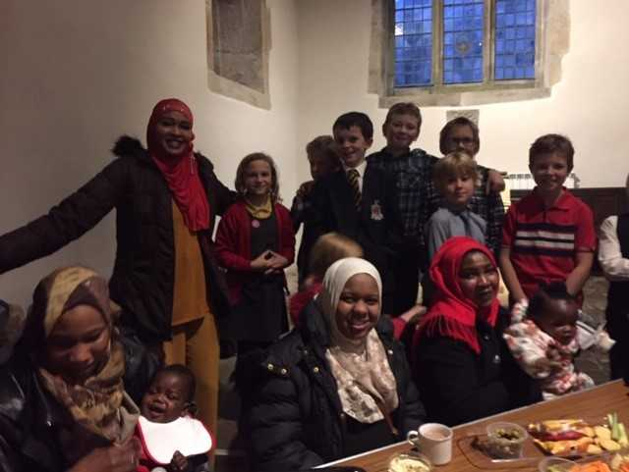
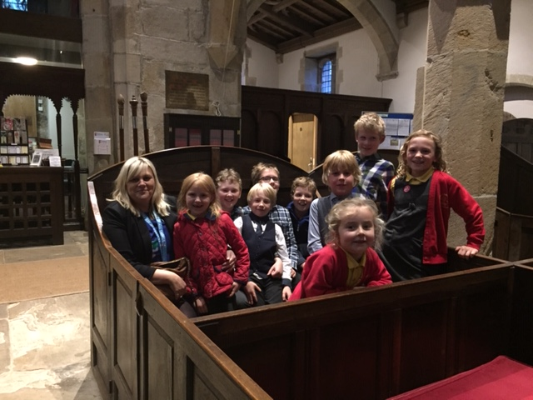

Accordian – Accordian is proving very popular with Mr Hinchcliffe so unfortunately there are no more spaces available.
After School Club – The After School Club is running extremely well and the children are enjoying the daily clubs. Coming soon on our website will be an After School Club page, which will highlight the fantastic sessions we offer each night. Sessions taken by your children will be added to ParentPay (except for those who have paid until half term) and last week/this week’s pay as you go bookings will be added too at the end of this week. Please check your ParentPay accounts weekly and pay the balance as soon as possible. If you want to book your child/children in please do so before 10.00 am on the day or ideally before.
Please note that Baking Betty is not going to be held on another night so please book early as the club can only take 16. Coming soon ……. Monday Construction Club – more details soon.
Please collect your children from 5.50 pm – any problems please ring the school on 01729 830214 and keep ringing if no reply, please do not leave a voice mail.
Start of the School Day – please be aware that school does not open until 8.45 am every morning.
Children dropped off before this time are the parents responsibility until a member of staff is on the playground at 8.45 am – thank you.
Parking – thank you for your continued help with this at the start and end of the day. The bus needs to get as close to the gate as possible to drop and collect the children safely.
School Uniform – We still have unnamed or incorrectly named uniform being worn by the children in school. Please name your children’s clothes, especially jumpers and cardigans.
Lost Property – Lacey has lost her new school cardigan aged 7/8, Also Thomas F has lost his spotty Otter red waterproof coat worn last Friday at Forest Friday – please check at home and in your children’s bags for these items. They are not at school.

NUT FREE SCHOOL – please be aware that we are a nut free school. Snacks that children in KS2 bring into school must only be fruit and vegetables, no cereal bars etc. Also, any cardboard for junk modelling should not be from a food source – no cereal boxes etc. Many thanks for your help with this.
Flu jabs – These are taking place this Friday morning. I have had a list sent from Childhood Immunisations with the names of children having the vaccination.
Book Club Class 1 – Book Club is going well and thank you for your support. Please free to come on Mondays from 3.00pm. Please sign in at reception – thank you.
Governors – please look on our school website on the Governor section to familiarise yourselves with our school's Governing Body. We have also created a new PTA page, which is under the Parents tab on the top task bar on the website too.
Headteacher Contact - If anyone would like to contact Mr Wright please do so at headteacher@settle-pri.n-yorks.sch.uk
Celebration Assembly – Please note the next one will be Thursday 25th October at 2.45 pm
Half Term
Please note that the children are back in school after half term on Tuesday 6th November.
Diary Dates
Fri 12th Oct | Am – Rec – Y5 flu vaccinations
Wed 17th Oct | Am Settle College Assembly for Y5/6
Mon 22nd Oct | 9.15 am Fire Safety Assembly re. Bonfire Night
Thurs 25th Oct | 2.45 pm Celebration Assembly
Fri 26th Oct | 3.30 pm Half Term Holiday
Tues 6th Nov | 9.00 am School opens
Wed 21st Nov | Tempest Photography taking Portraits and family photographs
Sun 9th Dec | Christingle Service at KM Church to include our school nativity play

School Uniform – We have been informed by our suppliers MC Sports that uniform is available to order online at http://www.mcsports.org.uk/kirkby-malham-primary-school/
You can also ring Mike on 01756 791688 or email him at mcsportsonline@gmail.com
GDPR – Privacy Notice for Parents and Pupils
The latest Privacy Notice for Parents and Pupils can be seen on our school’s website under Statutory Information
Safeguarding Notice
Kirkby-in-Malhamdale United V.A Primary School is committed to ensuring the welfare and safety of all children in school. All North Yorkshire schools, including Kirkby-in-Malhamdale Primary School, follow the North Yorkshire Safeguarding Children Board procedures. The school will, in most circumstances, endeavour to discuss all concerns with parents about their child/ren. However, there may be exceptional circumstances when the school will discuss concerns with Social Care and/or the Police without parental knowledge (in accordance with Child Protection procedures). The school will, of course always aim to maintain a positive relationship with all parents. The school’s child protection policy is available in the policies section of the web site.

