Kirkby-in-Malhamdale United (VA) Primary School,

Kirkby Malham,

Skipton,

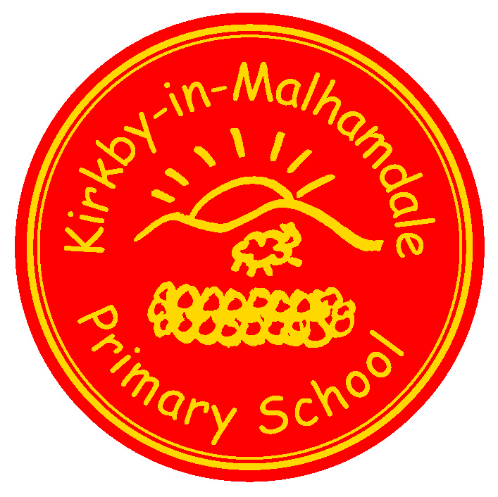
North Yorkshire,

BD23 4BY.

Telephone and Fax: 01729 830214
e-mail: admin@kim.n-yorks.sch.uk

Executive Headteacher: Mr Richard Wright

NEWSLETTER Autum 4 – 25th October 2018

n
 | Certificates - General Achievement and Writer of the Week
Class 1 | Daisy, Connie, Charlie
Class 2 | Harry H
Class 3 | William and Madeline

Captain’s Table –
Fri 12th Oct: William. Joshua, Oliver, Hallam, Aimee, Hance, Charlotte, Mia, Abigail
Fri 19th Oct: William, Harry H, Daisy, Betsy, Connie, Charlie, Carys, Madeline.
Well done to all the children who have been recognised for their hard work and effort in all areas in the last two weeks – keep it up!
Fire Safety Assembly and Bonfire Night Talk – Joshua writes ‘On Monday a Firefighter from Skipton came into school to talk to us about bonfire night. He told us never to go near the fire or fireworks even if they have not gone off. I think we all know how to stay safe now’.
Half Term Round up of events – Thomas writes ‘This term has been a new challenge for everyone as there have been new subjects and after school clubs that have been very popular and Mr Wright is doing a great job of being the Executive Headteacher. I think having three classes is going great as you get more attention in class and sporting events are going really well too. We have several children going through to Dalby Forest Cross Country next year in March and we are a very successful school in sporting events. Overall, I think the teachers are doing a great job and I will miss this school when I leave next year and wish everyone a happy holiday. Next half of term I am looking forward to carrying on with the new subjects such as specific rugby teachers and a maths only teacher and the popular ICT classes which are really fun and a great idea. Our school is a great school and always will be’.
Forest School an Outdoor Classroom – Mrs Middleton would like to extend a huge thank you to all parents who have so kindly contributed to our outdoor classroom area. The response has been overwhelming and Class 1 look forward to showing parents how all the materials have been up-cycled to create a very exciting learning environment.

Panto – We are in the process of booking a whole school trip to the Pantomime the last week of term – details to follow.
Summer Reading Challenge 2018 – Certificates have been given to the following children who took part in the Summer 2018 Reading Challenge:- Ben, Carys, Betsy, Frank, Jack, Thomas, Edward, Thomas, Emily, Oliver,
Joshua, Jacob and Charlie – well done to those children.
After School Club – The After School Club is running extremely well and the children are enjoying the daily clubs. On our website is an After School Club page, which will highlight the fantastic sessions we offer each night. Booking forms have been sent out for the rest of term for your completion. Weekly lists will be collated tomorrow (Friday 26th Oct) so if you haven’t sent your booking form in please do so in the morning. As these sessions get booked up very quickly it would be wise to pre-book but it is still possible to book in before 10.00 am on the day if there are spaces available. If you can book in advance this is most helpful as it enables the food shopping to be done accurately. Sessions taken will be added to ParentPay weekly. Please check your account on a regular basis and pay for the sessions taken – thank you.
Please collect your children from 5.50 pm – any problems please ring the school on 01729 830214 and keep ringing if no reply, please do not leave a voice mail.
Start of the School Day – please be aware that school does not open until 8.45 am every morning.
Children dropped off before this time are the parents responsibility until a member of staff is on the playground at 8.45 am – thank you.
Parking – thank you for your continued help with this at the start and end of the day. The bus needs to get as close to the gate as possible to drop and collect the children safely.
School Uniform – We still have unnamed or incorrectly named uniform being worn by the children in school. Please name your children’s clothes, especially jumpers and cardigans.
NUT FREE SCHOOL – please be aware that we are a nut free school. Snacks that children in KS2 bring into school must only be fruit and vegetables, no cereal bars etc. Also, any cardboard for junk modelling should not be from a food source – no cereal boxes etc. Many thanks for your help with this.
Book Club Class 1 – Book Club is going well and thank you for your support. Please free to come on Mondays from 3.00pm. Please sign in at reception – thank you.
Governors – please look on our school website on the Governor section to familiarise yourselves with our school's Governing Body. We have also created a new PTA page, which is under the Parents tab on the top task bar on the website too.
Headteacher Contact - If anyone would like to contact Mr Wright please do so at headteacher@settle-pri.n-yorks.sch.uk
Next Celebration Assembly - Thursday 22nd November at 2.45 pm
Half Term
Please note that the children are back in school after half term on Tuesday 6th November.

Diary Dates
Fri 26th Oct | 3.30 pm Half Term Holiday
Tues 6th Nov | 9.00 am School opens
Wed 21st Nov | Tempest Photography taking Portraits and family photographs
Fri 16th Nov | School Nursing Team – Hearing Test for Y1
Wed 21st Nov | 1.30 pm Tempest Photographers for Portraits and Family Photos – details to follow
Thurs 22nd Nov | 2.45 pm Celebration Assembly
Thurs 6th Dec | Y3-Y6 Cross Country at Giggleswick Junior School – details to follow
Sun 9th Dec | Christingle Service in Kirkby Malham Church to include our school nativity play **(see below)
Fri 14th Dec | Christmas Jumper Day in aid of Save The Children
Tues 18th Dec | Dance Showcase with Howard for Parents  School Christmas Lunch
Fri 21st Dec | Christmas Assembly (time tba)  3.30 pm End of Term  NB. No After School Club

** Please let us know if your child is unavailable for the Christingle at 5.00 pm on Sunday 9th December as we will be starting rehearsals soon

School Uniform – We have been informed by our suppliers MC Sports that uniform is available to order online at http://www.mcsports.org.uk/kirkby-malham-primary-school/
You can also ring Mike on 01756 791688 or email him at mcsportsonline@gmail.com
GDPR – Privacy Notice for Parents and Pupils
The latest Privacy Notice for Parents and Pupils can be seen on our school’s website under Statutory Information

Safeguarding Notice
Kirkby-in-Malhamdale United V.A Primary School is committed to ensuring the welfare and safety of all children in school. All North Yorkshire schools, including Kirkby-in-Malhamdale Primary School, follow the North Yorkshire Safeguarding Children Board procedures. The school will, in most circumstances, endeavour to discuss all concerns with parents about their child/ren. However, there may be exceptional circumstances when the school will discuss concerns with Social Care and/or the Police without parental knowledge (in accordance with Child Protection procedures). The school will, of course always aim to maintain a positive relationship with all parents. The school’s child protection policy is available in the policies section of the web site.

