Kirkby-in-Malhamdale United (VA) Primary School,

Kirkby Malham,

Skipton,

North Yorkshire,

BD23 4BY.

Telephone and Fax: 01729 830214
e-mail: admin@kim.n-yorks.sch.uk

Executive Headteacher: Mr Richard Wright

NEWSLETTER Autum 5 – 15th November 2018

n
 | Certificates - General Achievement and Writer of the Week | KiM
Class 1 | Ben P, Thomas, Abigail, Mia | Harriet
Class 2 | Edward, Harry E | Jacob
Class 3 | Katy, James, Thomas, Hallam, Frank, Alice, Matthew | Victoria

Captain’s Table –
Fri 26th Oct: Joshua, Lucy, Harriet, Frank, Jacob, Elliot, Ruby, Victoria and Alice.
Fri 9th Nov: Tyler, Katy, Jacob, Victoria, Sophie, Thomas S, James M, Ben P and William
Well done to all the children who have been recognised for their hard work and effort in all areas in the last two weeks – keep it up! Look out for the photos every Friday on Facebook of the lucky recipients.
Panto – We have booked for the whole school to go and see ‘Sleeping Beauty’ at King George’s Hall in Blackburn on Wednesday 19th December. The PTA have kindly offered to pay for the transport and details will follow regarding ticket price and plans for the day.
Tempest Photography – Tempest Photographers are in school on Wednesday 21st November to take the children’s individual portraits and family photos. Any younger siblings can come at 3.15 pm for a full family shot but can you let either Ali or Christine know if you are bringing extra children.
Nativity Play at The Chistingle Service Sunday 9th December 5pm – we are looking forward to our school Nativity which is taking place during the Christingle Service on Sunday 9th December at 5.00 pm. We have started this week looking through the script and learning the songs. If your child is not going to be available on Sunday the 9th please let us know as soon as possible.
Parent Consultation Evenings – These are to be held on the Wednesday the 5th and Thursday the 6th of December – more details to follow next week
After School Club
After School Club continues to flourish and we are now offering quiet play and Christmas crafts on a Thursday up until Christmas with Art and Craft Club carrying on at the beginning of next term.

We are holding a disco on Thursday 20th December from 5.00 – 7.30 pm to include tea. This will be instead of the usual ASC and will be charged at the usual £10 per child. If you would like your child/children to join in this fun evening please let Christine or Ali know - many thanks.
A few parents have asked if it is possible to set up alerts to remind them to pay within the communication element of their ParentPay account. This is possible so please see the guidance notes below for whoever would like to set this up.
https://www.parentpay.com/DOCH/school-support/wp-content/uploads/2018/05/How-to-set-up-alerts.pdf
Please collect your children from 5.50 pm – any problems please ring the school on 01729 830214 and keep ringing if no reply, please do not leave a voice mail.
Christmas Wreath Making Evening – This is to be held at school on Friday 30th November, tickets are £25 where you will be able to make a beautiful wreath under the guidance of florist Sophie Eddleston (plus a festive tipple) – please contact Sophie for tickets at sophietaz2000@yahoo.co.uk
Rocking Rhymes – On Monday Sally-Anne Brown started Mini Minims for babies and pre-school children in the hall from 10.00 – 11.30 am. This proved a very successful group and lots of mums and grannies came with their little ones for a fun time, singing and dancing with drinks included. Please spread the word of this fantastic group
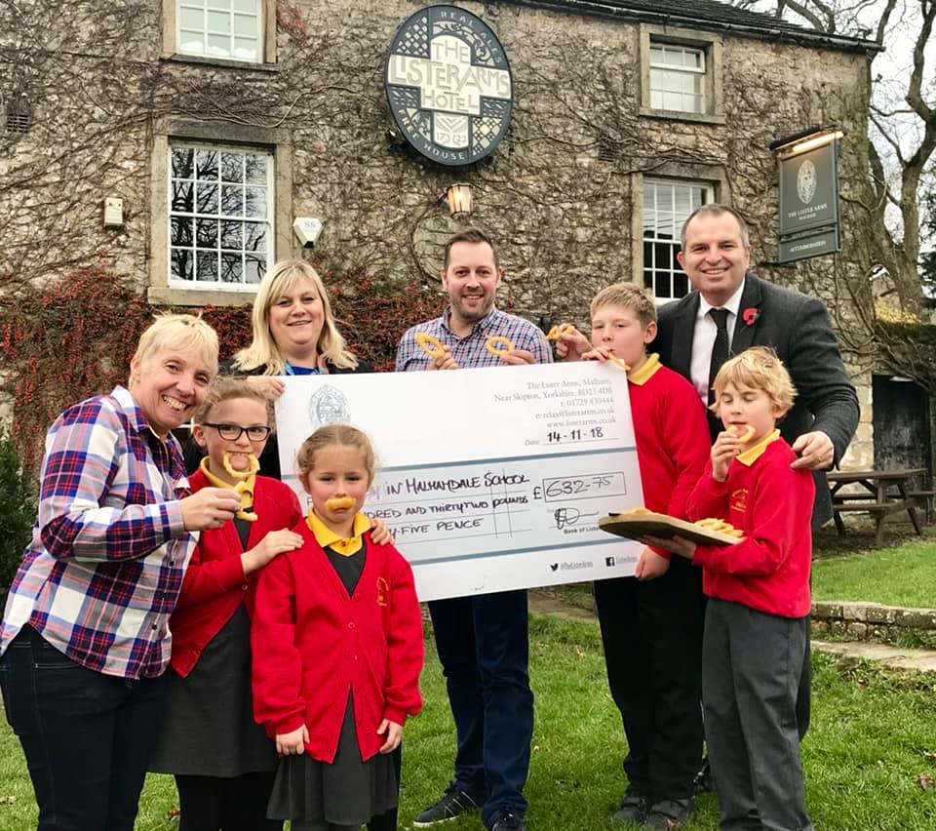

Onion Rings! – The Lister Arms at Malham have once again donated a large cheque for £632.75 for extra portion of onion rings sold. This money will go towards resources for the After School Club. Thank you to Darren and his team at the Lister Arms.
Malham Safari – The committee of the Malhamdale Safari have donated a massive £3,500 to school to go towards resources for the children – we are very grateful for this very kind donation.
Craven Herald – We have had an apology from the Craven Herald regarding a photograph of our new starters which should have been included in this week’s issue. It was a lovely picture of our children commemorating Remembrance Day. They have assured us that this will be included next week but have put it on their website as from today.
Start of the School Day – please be aware that school does not open until 8.45 am every morning.
Children dropped off before this time are the parents responsibility until a member of staff is on the playground at 8.45 am – thank you.

Parking – thank you for your continued help with this at the start and end of the day. The bus needs to get as close to the gate as possible to drop and collect the children safely. You may have noticed that the field adjoining the playground has been turned in to a car park for those busy times at school. This is not only to allow the bus access to the school but assist parents in parking off the road. Please use this area to park in. Thanks.
School Uniform – We still have unnamed or incorrectly named uniform being worn by the children in school. Please name your children’s clothes, especially jumpers and cardigans. All unnamed clothing is put in the lost property box in the corridor.
PE – your children are accessing lots of outdoor sports and this in turn, at this time of year, on a soft muddy field is creating lots of messy PE kits, especially joggers. The concern is that the muddy joggers are being placed back in PE bags and then got back out the day after still wet and muddy, this is then making the whole PE kit a mess. We are encouraging them to leave trainers out of the bag and then they have a chance overnight to dry out. I realise an overnight wash is not always possible and so I don’t really have an answer. Possibly an extra pair of joggers, or carrier bag that at least separate the joggers from the rest of the kit. Please have a word with your child if you want their kit home.

CHILDREN IN NEED – this Friday is Children in Need to mark this your child may come in non-uniform. (for a small donation) Also to mark Anti-Bullying week we are marking this by wearing odd socks.
NUT FREE SCHOOL – please be aware that we are a nut free school. Snacks that children in KS2 bring into school must only be fruit and vegetables, no cereal bars etc. Also, any cardboard for junk modelling should not be from a food source – no cereal boxes etc. Many thanks for your help with this.
Book Club Class 1 – Book Club is going well and thank you for your support. Please free to come on Mondays from 3.00pm. Please sign in at reception – thank you.
Governors – please look on our school website on the Governor section to familiarise yourselves with our school's Governing Body. We have also created a new PTA page, which is under the Parents tab on the top task bar on the website too.
Headteacher Contact - If anyone would like to contact Mr Wright please do so at headteacher@settle-pri.n-yorks.sch.uk
Next Celebration Assembly - THURSDAY 22ND NOVEMBER AT 2.45 PM

DIARY DATES
Fri 16th Nov | Children In Need Day – Non Uniform (please bring a small donation) and/or Anti-Bullying week – odd socks (please bring a small donation)
Fri 16th Nov | Y1 Hearing Test with School Nursing Team
Wed 21st Nov | 1.30 pm Tempest Photography taking Portraits and family photographs
Thurs 22nd Nov | 2.45 pm Celebration Assembly
Wed 5th December | Parent Consultation Evening
Thurs 6th Dec | Y3-Y6 Cross Country at Giggleswick Junior School – details to follow  Parent Consultation Evening
Sun 9th Dec | Christingle Service in Kirkby Malham Church to include our school nativity play 5pm
Fri 14th Dec | Christmas Jumper Day in aid of Save The Children
Tues 18th Dec | Dance Showcase with Howard for Parents 3pm  School Christmas Lunch
Wed 19th Dec | Pm Christmas Panto ‘Sleeping Beauty’ at King George’s Hall, Blackburn
Thurs 20th Dec | ASC Christmas Disco 5 – 7.30 pm – Let Ali/Christine know if your child wishes to attend
Fri 21st Dec | Christmas Assembly 2.30pm  3.30 pm End of Term  NB. No After School Club

School Uniform – We have been informed by our suppliers MC Sports that uniform is available to order online at http://www.mcsports.org.uk/kirkby-malham-primary-school/
You can also ring Mike on 01756 791688 or email him at mcsportsonline@gmail.com
GDPR – Privacy Notice for Parents and Pupils
The latest Privacy Notice for Parents and Pupils can be seen on our school’s website under Statutory Information

Safeguarding Notice
Kirkby-in-Malhamdale United V.A Primary School is committed to ensuring the welfare and safety of all children in school. All North Yorkshire schools, including Kirkby-in-Malhamdale Primary School, follow the North Yorkshire Safeguarding Children Board procedures. The school will, in most circumstances, endeavour to discuss all concerns with parents about their child/ren. However, there may be exceptional circumstances when the school will discuss concerns with Social Care and/or the Police without parental knowledge (in accordance with Child Protection procedures). The school will, of course always aim to maintain a positive relationship with all parents. The school’s child protection policy is available in the policies section of the web site.

