Kirkby-in-Malhamdale United (VA) Primary School,

Kirkby Malham,

Skipton,

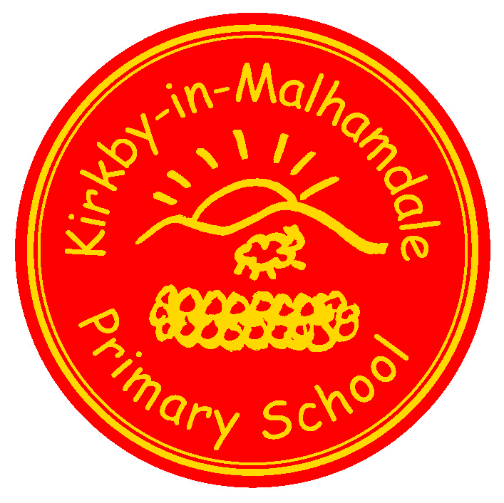
North Yorkshire,

BD23 4BY.

Telephone and Fax: 01729 830214
e-mail: admin@kim.n-yorks.sch.uk

Executive Headteacher: Mr Richard Wright

NEWSLETTER Autumn 8 w/c 14th January 2019

 | Certificates - General Achievement and Writer of the Week | KiM
Class 1 | Vincent, Violet | Connie
Class 2 |  | Ruby
Class 3 | William H | Alice
Captain’s Table on Friday 11th January – William H, Oliver, Vincent, Harry E, Ruby, Alice, Connie, Violet and Betsy
Welcome to the start of the Spring Term 2019 and a very happy new year to everyone.
PTA Supper Night – 22nd February 2019 at 7.00 pm - We are holding our biennial supper night this coming February at Town End Farm shop. It’s a great night with lots of lovely food and fun had by all. It will be held on the final Friday of next half term so please put the date in your diary now. More information re price and tickets etc will be sent out at the beginning of next term.
The supper night includes an "Auction of Promises" so if you have anything to offer please let Becky Cartman know as she is our auction organiser. Thanks Victoria
Parent View Questionnaires – Just a reminder to complete the parent view questionnaire at https://mobile.parentview.ofsted.gov.uk/parent-view-results - many thanks
After School Club
After School Club is going well. If you need a booking form please ring the office or please send forms in if you wish your children to go to ASC. You can also ring and book them in. Payment for the clubs has changed and instead of paying the tutors direct we are putting your children’s attendance on ParentPay under After School Club. Please do not send any more cheques to the tutors, just look on ParentPay and pay weekly – thank you.
Please note that Football (Tues after half term) and Fitness (Wednesdays) are for the whole school, not just KS2)
ParentPay
Please keep checking your ParentPay accounts and settle any outstanding debts. There are amounts from the After School Club Christmas Disco still outstanding so please pay these as soon as possible – thank you.
ParentPay alerts can be set up on https://www.parentpay.com/DOCH/school-support/wp-content/uploads/2018/05/How-to-set-up-alerts.pdf
Rocking Rhymes – On Monday mornings Sally-Anne Brown runs Mini Minims for babies and pre-school children in the hall from 10.00 – 11.30 am. This is a fun group for mums and grandparents which includes singing and dancing with drinks included. Please spread the word about this fantastic group.
Swimming for Y1 – Y4- Swimming started last week and went very well, the children were put in groups according to their ability – please can these sessions be paid for on ParentPay – thank you.

Class 2 Trip to Salt’s Mill – Class 2 are going to Salt’s Mill, Saltaire on Wednesday 23rd January to learn more about the artist David Hockney. They will be travelling from Skipton to Saltaire on the train – details to follow.
Class 1 Trip to Skipton Castle – this will take place during the second half of term – details to follow
Y2 Indoor Athletics – This takes place on Friday 25th January at Gigglewick Sports Hall – details will follow soon.
Swimming Gala – This takes place at Settle Pool on Friday 8th February – details to follow.
Green Tree Award - We are working hard to achieve our Platinum Green Tree Award. An easy way we can earn extra points is to recycle Christmas cards. After Christmas we will be collecting cards for recycling, we would be grateful if you would please hold on to yours and send them into school with your child.
Start of the School Day – Please be aware that school does not open until 9.00 am every morning but you may arrive from 8.45am. Children dropped off before this time are the parents responsibility until a member of staff is on the playground at 8.45 am – thank you.
Parking – Thank you for your continued help with this at the start and end of the day. The bus needs to get as close to the gate as possible to drop and collect the children safely. You may have noticed that the field adjoining the playground has been turned in to a car park for those busy times at school. This is not only to allow the bus access to the school but assist parents in parking off the road. Please use this area to park in. Thanks.
School Uniform – We still have unnamed or incorrectly named uniform being worn by the children in school. Please name your children’s clothes, especially jumpers and cardigans (also swm wear too). All unnamed clothing is put in the lost property box in the corridor.
NUT FREE SCHOOL – Please be aware that we are a nut free school. Snacks that children in KS2 bring into school must only be fruit and vegetables, no cereal bars etc. Also, any cardboard for junk modelling should not be from a food source – no cereal boxes etc. Many thanks for your help with this.
This also means no other foodstuff eg. Birthday cakes, sweets, crisps etc. We take our safeguarding extremely seriously and we thank you for your cooperation with this.
Book Club Class 1 – Book Club is going well and thank you for your support. Please free to come on Mondays from 3.00pm. Please sign in at reception – thank you.
Governors – Please look on our school website on the Governor section to familiarise yourselves with our school's Governing Body. We have also created a new PTA page, which is under the Parents tab on the top task bar on the website too.
CELEBRATION ASSEMBLY – This will take place on Friday 25th January – everyone welcome.
Headteacher Contact - If anyone would like to contact Mr Wright please do so at headteacher@settle-pri.n-yorks.sch.uk
DIARY DATES
Wed 23rd Jan | Class 2 Trip to Salt’s Mill – details to follow
Fri 25th Jan | 9.30 – 11.30am Y2 Indoor Athletics – details to follow  2.45 pm Celebration Assembly
Fri 8th Feb | Swimming Gala at Settle Pool – details to follow

School Uniform – We have been informed by our suppliers MC Sports that uniform is available to order online at http://www.mcsports.org.uk/kirkby-malham-primary-school/
You can also ring Mike on 01756 791688 or email him at mcsportsonline@gmail.com
GDPR – Privacy Notice for Parents and Pupils
The latest Privacy Notice for Parents and Pupils can be seen on our school’s website under Statutory Information

Safeguarding Notice
Kirkby-in-Malhamdale United V.A Primary School is committed to ensuring the welfare and safety of all children in school. All North Yorkshire schools, including Kirkby-in-Malhamdale Primary School, follow the North Yorkshire Safeguarding Children Board procedures. The school will, in most circumstances, endeavour to discuss all concerns with parents about their child/ren. However, there may be exceptional circumstances when the school will discuss concerns with Social Care and/or the Police without parental knowledge (in accordance with Child Protection procedures). The school will, of course always aim to maintain a positive relationship with all parents. The school’s child protection policy is available in the policies section of the web site.

