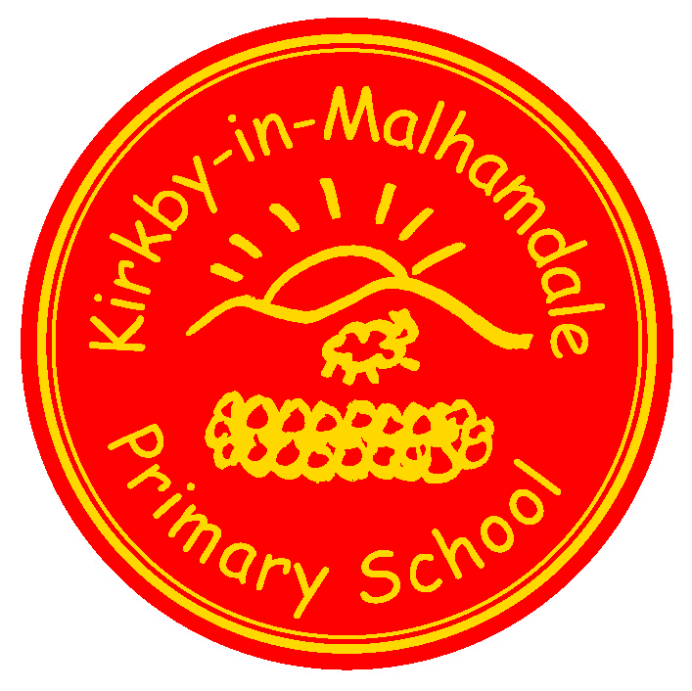
Kirkby-in-Malhamdale United (VA) Primary School,

Kirkby Malham,

Skipton,

North Yorkshire,

BD23 4BY.

Telephone and Fax: 01729 830214
e-mail: admin@kim.n-yorks.sch.uk
Acting Headteacher: Mr. C. Norris

NEWSLETTER 11 6th March 2017

CERTIFICATE AND KIM AWARD WINNERS
Congratulations to the children who were presented with certificates and KiM Awards at our Celebration Assembly on the Friday before the half-term holiday. They were:-

 | Certificates | KiM
Class 1 | Harry E. Matthew Barnes Madeline Frank | Alice M.
Class 2 | Carys Katy | Rafe

ROUND-UP OF RECENT EVENTS AND ACTIVITIES
- The PTA’s Supper Night and Auction of Promises, which took place at the Farm Shop in Airton on Saturday 13th February, was a huge success, and was characterised by delicious food, and a friendly and lively atmosphere. Many thanks to everyone who was involved in organising this event and also in making donations for the auction. In total, the evening raised well over £3,000 – a fantastic result.
- Our French Day on Monday 13th February was also a great success. We all enjoyed a French breakfast (including croissants, brioche and pain-au-chocolat) to start the day before we split into mixed-age groups for French bingo, French board games and listening to French stories. In the afternoon, we held a whole-school boules tournament and rounded the day off with French action songs. “Merci beaucoup,” Madame Rushton for organising the day, and hopefully there will be another French Day in the summer term.
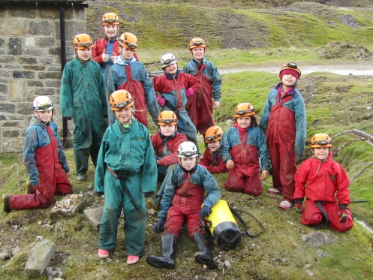
- Last week’s residential visit to Bewerely Park for the outdoor adventurous activities week was greatly enjoyed by all the children in years 4, 5 and 6. The parents of those children will have seen some photos of the different events and activities the children were doing, but if you would like to know more, please come along to our Celebration Assembly on Friday when we will be showing more photos and telling the story of the week. Meanwhile, here are a couple of pictures to whet your appetite.
- This half term we have started learning tennis in our Tuesday morning PE lessons. The first session last week got off to a very good start.

FORTHCOMING SPECIAL EVENTS AND ACTIVITIES
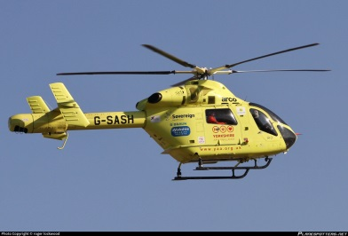
- Our World Book Day is on Friday this week, (10th March). We would like all the children to come to school dressed as a character from a book, and to bring that book with them so the two parts (character and book) go together. We would also like them to be able to say a little about their choice of book and character – this is something that parents may like to rehearse with their children at home. At the end of the day, as usual, all the children will receive a voucher entitling them to a reduced price book – full details, terms and conditions of this will be on the voucher, which is valid until 26th March and at our own Book Fair.
- Next Monday, we welcome the Malhamdale CAMEO Club (Come and Meet Each Other) into school for their meeting, which includes a talk by staff from the Yorkshire Air Ambulance and Afternoon Tea be served by the children. We would like to make next Monday a non-schoolwear day, where for £1 the children may come dressed in their casual clothes. All the money we raise will be donated to the Air Ambulance. It doesn’t need me to say what an essential service the Air Ambulance provides in a rural area like ours.
- Looking further ahead, Comic Relief – Red Nose - Day is on Friday 24th March. We will give more information about this in our next Newsletter.
- At the end of this Newsletter is a summary of the dates of other future events – please make a note of the dates and times now, and we will send further details in due course.

START OF THE SCHOOL DAY
I would be very grateful if parents who bring their children to school could do so after 8:40am. If children arrive earlier than this it is not possible for them to be supervised (in the playground or in school) while staff are preparing lessons for the day. There are also some occasions when other services (e.g. the “bin men”) need to do their jobs early and so we need to be sure that the playground is empty. Your help and co-operation is much appreciated.

SUMMARY OF DATES OF FORTHCOMING EVENTS
March
Fri. 9th Our World Book Day
2:45pm – Celebration Assembly
Mon. 13th 1:30 – 3:30pm - Malhamdale CAMEO Club and the Yorkshire Air Ambulance in school.
Wed. 15th 7:30pm – Governing Body Meeting
Fri. 17th Next Newsletter
w/c Mon. 20th Assessment week for all children
Mon. 20th 3:45pm – School Improvement and Curriculum Meeting (change from Mon. 13th t.b.c.)
Thur. 23rd North Yorkshire Cross-Country Championships at Dalby Forest, nr. Pickering (for selected children)
Fri. 24th Comic Relief – Red Nose Day
Mon. 27th & Tue. 28th “Bikeability” training for children in Years 5 and 6.
w/c/ Mon. 27th Parent – Teacher children’s progress meetings
Tue. 28th – Mon. 3rd April School Book Fair (details to follow)
Fri. 31st afternoon – Easter Fair
April
Wed. 5th 9:30 – 11:30am – Open Morning

Chris Norris, Acting Headteacher

