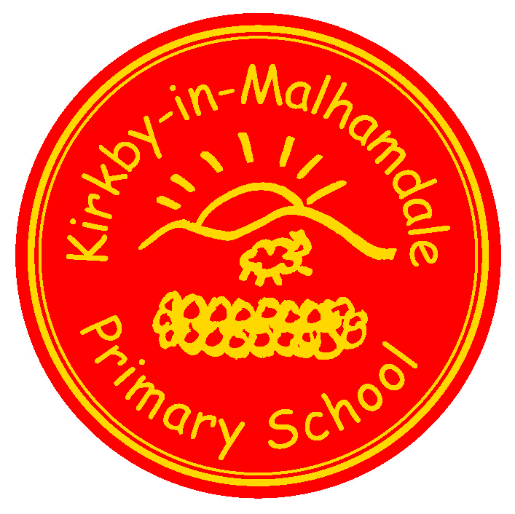
Kirkby-in-Malhamdale United (VA) Primary School,

Kirkby Malham,

Skipton,

North Yorkshire,

BD23 4BY.
Telephone and Fax: 01729 830214
e-mail: admin@kim.n-yorks.sch.uk
www.kirkby.schooljotter2.com
Interim Headteacher: Mr. C. Norris

NEWSLETTER 12 17th March 2017

CERTIFICATE AND KIM AWARD WINNERS
Congratulations to the children who were presented with certificates and KiM Awards at our Celebration Assembly last Friday. They were:-

 | Certificates | KiM
Class 1 | Ruby Harry H Betsy Lucy | Madeline
Class 2 | Hance James John Lisa William | Oscar

ROUND-UP OF RECENT EVENTS AND ACTIVITIES
- Our World Book Day on Friday last week went superbly well. All the children looked fantastic dressed as a character from a book, and I would like to express my thanks to all parents who helped them with their costumes. At the end of the day, all the children received a voucher entitling them to a reduced price book, which is valid until 26th March and also at our own Book Fair later this month.
- On Monday, we welcomed the Malhamdale CAMEO Club (Come and Meet Each Other) into school for their meeting, which included a talk by staff from the Yorkshire Air Ambulance and Afternoon Tea served by the children. As a result of the children’s non-schoolwear day, we were able to make a donation of £50 to the Air Ambulance, which is such an essential service in our rural area.

FORTHCOMING SPECIAL EVENTS AND ACTIVITIES
- Next week is our Assessment Week for all children in both classes.
- On Thursday next week, 5 children – Jessie, Finlay, Fraiser, Alice E & Anna – are representing Craven District by taking part in the North Yorkshire schools Cross-Country Championships at Dalby Forest, near Pickering. It is a tremendous achievement to have qualified to reach this stage of the competition, and we wish them all every success as they participate in their races.
- Next Friday, 24th March, is Comic Relief – Red Nose Day. Children can come to school dressed in red, and make a £1 donation to Comic Relief. Of course, if they have one, they may also wear their Red Noses. During the day, we will be doing some special Red Nose Day activities.
- Also next Friday, our Celebration Assembly at 2:45pm will be a special assembly for Mother’s Day.
- Our parish church, St. Michael the Archangel, is holding a special service for Mother’s Day on Sunday 26th March. All families are invited to go to this service, which starts at 10.00 am.
- Information has been sent home about our Parent-Teacher Pupil Progress Meetings, which will be held on Monday 27th and Thursday 30th March. Please complete the reply form and return it to school by next Monday.
- Our Book Fair will run from Tuesday 28th March to Monday 3rd April. Towards the end of these days, parents are welcome to come into school to see and buy from the selection of books available. World Book Day vouchers can also be used.
- We hope all families and friends will come to school from 1:30pm on the afternoon of Friday 31st March for our Easter Fair. This promises to be a very enjoyable afternoon, with the children running various stalls and activities. PTA are running a cake stall so any cakes/buns/biscuits would be gratefully received. As usual we will be holding a raffle and would ask for any hamper items ie. tins, bottles, pasta, chocolate goods, smellies etc to be sent to school (bottles by parents please) as soon as possible but before Wednesday 29th March so we can make up the hampers. Any other donations for the raffle would be also gratefully received.

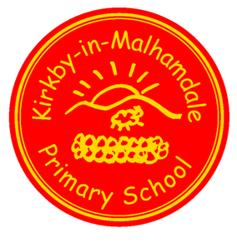
OPEN MORNING
Wednesday 5th April 2017
9.30am – 11.30am
EVERYBODY WELCOME TO COME AND SEE OUR FANTASTIC SCHOOL IN ACTION
We look forward to welcoming prospective parents, current parents and all who have an interest in the school.
Refreshments served.
- Following on from the very encouraging response to our Open Morning last term, our next Open morning will be on Wednesday 5th April from 9:30am to 11:30am. Mums, dads, other family members and friends, prospective parents, members of the local community (and visitors as well!) are all welcome to come into school on that day to see what we do in the classes, meet the children and staff, and join in with the lessons.
- At the end of this Newsletter is a summary of the dates of other future events – please make a note of the dates and times now, and we will send further details in due course.

START OF THE SCHOOL DAY
After the request in the previous Newsletter, we are very grateful to for seeing the children coming to school from 8:40am onwards. Thank-you.

SUMMARY OF DATES OF FORTHCOMING EVENTS
March
w/c Mon. 20th Assessment week for all children
Mon. 20th 3:45pm – School Improvement and Curriculum Meeting
Tue. 21st 4pm - Governing Body – additional meeting
Thur. 23rd North Yorkshire Cross-Country Championships at Dalby Forest, nr. Pickering (further information has previously been sent to parents of selected children)
Fri. 24th Comic Relief – Red Nose Day
2:45pm – Mother’s Day Celebration Assembly
Sun. 26th 10.00am – Mother’s Day service on behalf of the church at St. Michael the Archangel Church, Kirkby Malham.
Closing date for using World Book Day vouchers but can be used at our Book Fair
Mon. 27th & Tue. 28th “Bikeability” training for children in Years 5 and 6 (letter to follow)
Mon. 27th 3:30-6:30pm - Parent – Teacher children’s progress meetings
Tue. 28th – Mon. 3rd April School Book Fair
Thur. 30th 3:30-6:30pm - Parent – Teacher children’s progress meetings
Fri. 31st 1:30-3:30pm – Easter Fair
Next Newsletter
April
Tues 4th WOP Music Concert for all parents pm (time to be arranged)
Wed. 5th 9:30 – 11:30am – Open Morning
Fri. 7th 2:45pm – Celebration Easter Assembly
3:30pm – School closes for the Easter holiday
Mon. 24th Staff training day.
Tue. 25th 9am – school re-opens for children for the start of the summer term.

Chris Norris – Interim Headteacher

