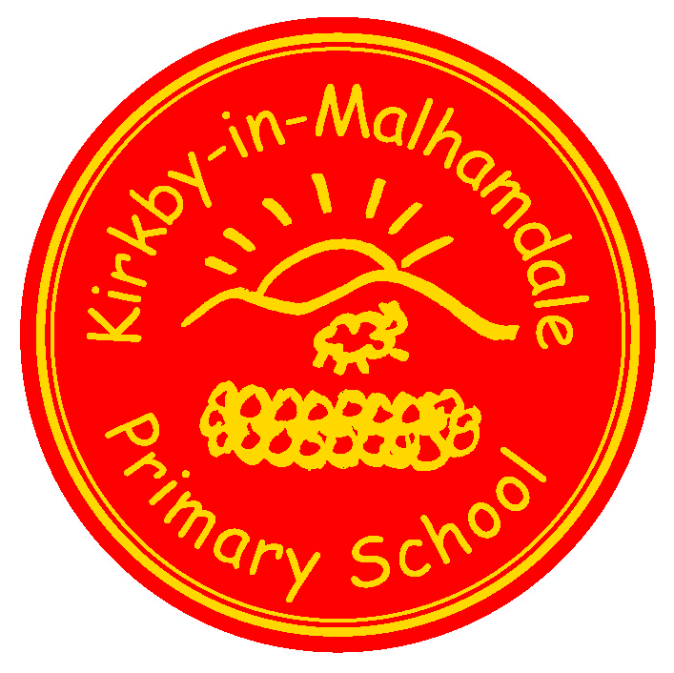
Kirkby-in-Malhamdale United (VA) Primary School,

Kirkby Malham,

Skipton,

North Yorkshire,

BD23 4BY.

Telephone and Fax: 01729-830214
e-mail: admin@kim.n-yorks.sch.uk
www.kirkby.schooljotter2.com

Executive Headteacher: Mrs. Sarah Peel

NEWSLETTER 21st September 2017

We are delighted that all the children have settled into the new school year extremely well. This newsletter will be issued fortnightly, continuing on a Thursday. This is our main way of communicating, so please take note, and ask questions where you aren’t sure.

Timetables
These are attached for Class 1 and 2. We hope you find it useful in helping your child to talk about what they have learned in school.

Cross Country Congratulations
Congratulations to everyone who took part in the Cross Country race at Aireville Pitch & Putt, we sent 20 children, namely, Frank, Barnes, Alice, Ben, Rafe, Thomas, Willliam, John, Preston, Anna, Sophie, Victoria, Oliver, Carys, Hance, Fraiser, Jessie, Finley, Jack and Rhiannon. Everyone did brilliantly, especially, Finley, Jessie, Fraiser, Anna, Alice and Hance who all qualified for the Craven School Games Cross Country Final! Details for those 6 children to take part are at the end of the newsletter.

Class 2 Voices of the Land Visit to Malham
Class 2 enjoyed a visit to Hill Top Farm in Malham last Thursday to meet farm owner, Neil Heseltine who showed the children around his farm. The visit included walking to see his cows (belted Galloways) and sheep (black faced Wensleydales). Harriet and Rob from the Voices of the Land team gave the children lots of interesting information. Today, 21st September Harriet and Rob have come to school to make collages and a short film using all the information they learnt on the farm last week.

Settle College Open Day Y5/6
On Thursday 28th September Y5 and Y6 will be spending the afternoon at Settle College with a view to moving to secondary school. Increasingly, this school has been chosen by parents and we encourage all pupils to participate in this free event. If you wish your child not to go, please can you write a note for Mr Bell. Don’t forget the Open Evening that night from 6.00pm – 8.00pm.

Harvest Assembly and Macmillan Coffee Afternoon
This will be held on Friday 6th October in school at 1.30 pm. Any cakes, buns or biscuits would be very gratefully received and all money raised will go towards Macmillan Cancer Support. Parents, grandparents and friends all very welcome. Also fruit/veg/cans and produce can be brought for the Harvest Assembly. Last year we donated our produce to Neville House in Gagrave and they were very grateful.

Parents Evenings – 11th and 12th October
Mr Bell and Mrs Allen will be holding parents evenings on these dates. The weekend before your child will bring home all their books for you to look through, please return the books on the Monday. Appointments are for 10 minutes each but if there is more to discuss then an additional appointment will be made. Meetings will take place in Class 2 for Mr Bell and the Library for Mrs Allen. Appointments are for parents only, not pupils, There will be a table in the hall with resources on if you need to bring your children along.

In order to plan appointments, please return the slip below with your preferred time. We shall endeavour to do our best to accommodate everyone.

Saturday 14th October – Grounds morning – please put the date in your diary – more the merrier – 10am – 12pm.

School Gates
We would ask parents to please stand inside the school wall in the railed fence area to wait for their child/children. We are always concerned about any children running around in the car park as it does get extremely busy both ends of the day – thank you.

P E Kit
Please can all children come to school with their PE kit each week plus outdoor trainers and joggers and fleece as the weather gets colder.

Attendance
Please can you ensure your child arrives at school between 8.45 – 9am. Wake up Shake up is part of the school day. Also if your child is absent please can you contact the school office before 9am as we need this information for our electronic registers. Many thanks.

Thurs 21st Sept | Class 2 Farm Visit (2nd visit)
Fri 22nd Sept | 2pm PTA Meeting in hall followed by Celebration Assembly for all parents at 2.45 pm
Tues 26th Sept | 1pm Y3 Orienteering event
Fri 6th Oct  Fri 6th Oct | 1.30 pm Macmillan Coffee Afternoon and Harvest Festival Assembly  1-3pm Y3/4 Football Tournament (details to follow)
Wed 11th Oct | Parents Evening (1)
Thurs 12th Oct | Parents Evening (2)
Friday 13th Oct | 1-3pm Y5/6 Football Tournament (details to follow)
Sat 14th October | 10 – 12am Grounds Day for Parents
Mon 16th October | 3.30 pm After School Club Party
Fri 20th October | 2.45 pm Celebration Assembly –  3.30 pm Break up for Half Term

Finalists for Cross Country Please email Katie Hoggarth at khoggarth@carleton-endowed.n-yorks.sch.uk to confirm your child’s attendance on the 5th October. Arrive at 3.30pm so please collect your child from school at 3.15pm. Mrs Peel will be going this event.

Parents Evening Preferred Times: Please circle a time slot, sign and return as soon as possible.

Wednesday 11th Oct 3.30 – 4.30pm 4.30 – 6.00pm
Thursday 12th Oct 3.30 – 4.30pm 4.30 – 7.00pm

Signed ………………………………………………………………………….. Print ……………………………………………………………………………

