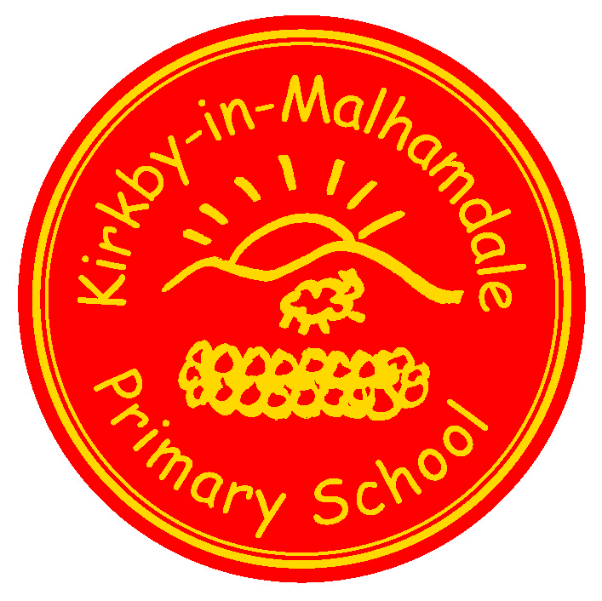
Kirkby-in-Malhamdale United (VA) Primary School,

Kirkby Malham,

Skipton,

North Yorkshire,

BD23 4BY.

Telephone and Fax: 01729 830214
e-mail: admin@kim.n-yorks.sch.uk

Executive Headteacher: Mrs S Peel
NEWSLETTER 3 – 5th October 2017

The newsletter will be issued fortnightly, continuing on a Thursday. This is our main way of communicating, so please take note, and ask questions where you aren’t sure. The next issue will be on Thursday 19th October.
Thank you so much for returning the contact forms, this enables us to up-date our data base. It is invaluable in creating lists for staff detailing collection arrangements and health/allergies. If there are any changes or you still have yours to hand in, please let the office know.
Y3 Orienteering – Mrs Cawood and Miss Harrison took the Y3 children to Sandylands, Skipton for a fun afternoon of orienteering. Craven College students took them around the activities where they enjoyed finding clues for each one. They all had a really good time.
Today is the Craven Schools Cross Country finals at Giggleswick, we wish Finlay, Jessie, Anna, Fraiser, Alice and Hance lots of luck in their races.
Harvest Assembly & Macmillan Coffee Afternoon
We look forward to seeing lots of you at school on Friday afternoon from 1.30 pm. Any donations of cakes/buns or biscuits to sell for Macmillan Cancer Research will be gratefully received and also produce donations for our Assembly such as fruit/veg/cans – they will be donated to a worthwhile cause as we did last year.
Also on Friday some of our Y3 & 4 children are competing in a 7-a-side Football Tournament in the afternoon at Sandylands. Mrs Cawood is taking the children in a mini bus. Don’t forget their shin pads!!
Parents Evenings Wed 11th and Thurs 12th October
Thanks to everyone who has returned their slips for their preferred times for parents evening. We are sending out today a letter with your child/children’s times. Please note that if the teachers need longer for discussion then a follow up meeting will be arranged. Your child will come home with their workbooks this weekend. Please look through and see their progress. These books need returning on Monday so they can be used in lessons. You should see marking in purple and green pens are used for pupils to respond to their feedback.
Please note the paragraphs underneath regarding After School Club on Thursday 12th October. If your child is already booked into the Club that evening you don’t need to do anything as Mrs Cawood will know.
Don’t forget that Saturday 14th October is Grounds Day, please bring your spades and shovels for a two hour dig in the wildlife area starting at 10 am.

After School Club News Mrs Cawood and Miss Harrison are running after-school care every Monday and Thursday. This has now come under the responsibility of the school and is an aspect of the ‘extended school’ provision we offer. Please make use of this facility as it has to be self-financing.
One popular activity they offer are the After School Club parties, the first this term being on Monday 16th October from 3.30 – 6.00pm. This will be a Halloween themed fancy dress party where prizes are given for the scariest costumes!! – letter sent tomorrow plus booking form for next half of term.
Christmas Fundraiser! We have attached with this letter a Christmas Card and Mug Fundraising Project for the children to take part in if they wish. They should design their own Christmas Card or Mug on the card provided and complete the order form as the letter explains. This can be done as an individual child or all siblings together, it’s up to you. This has to be back at school to send off by Friday 13th October so get drawing children and have a good time. I am sending one per family but if you need anymore, please let me know and I will photocopy more.
Uniform Please could your child’s uniform be correctly labelled with your family name. We are losing lots of uniform and it’s mostly down to incorrect labelling.
Medicine - Just a reminder that any prescribed medication your child needs at school must be brought in by the parent, a form completed and signed at reception before we can administer it. Unprescribed medication eg. Calpol, Cough Syrup etc cannot by administered by staff. However you can call into school and do it yourself if needed.
Junk Modelling Class One would be very grateful for any used boxes eg. egg boxes, toothpaste boxes etc etc – they are running very short – (not dishwasher or soap power) thank you.

Admission to Primary School 2018 If you have a child or know of a child who is eligible to start here in September 2018, please can you book their place at www.northyorks.gov.uk/schooladmissions- thank you.

Forthcoming Dates
Thurs 5th Oct | 3.30pm Cross Country Final at Giggleswick
Fri 6th Oct | 1 – 3 pm Y3&4 Football Tournament at Sandylands
 | 1.30pm Harvest Assembly & Macmillan Coffee Afternoon
Wed 11th Oct | Parents Eve (letter sent)
Thurs 12th Oct | Parents Eve (letter sent)
Fri 13th Oct | 1 – 3pm Y5&6 Football at Sandylands
Sat 14th Oct | 10-12pm Grounds Day
Mon 16th Oct | 3.30 – 6.00pm After School Club Halloween Party
Fri 20th Oct | 2.45pm Celebration Assembly  3.30pm Half Term Holiday
Mon 30th Oct | 9.00am School Opens
Thurs 2nd Nov | 9.30 – 2.45pm Y5&6 Exploring Religious Diversity at Settle College (details to follow)
Fri 10th Nov | 2.45 pm Celebration Assembly

