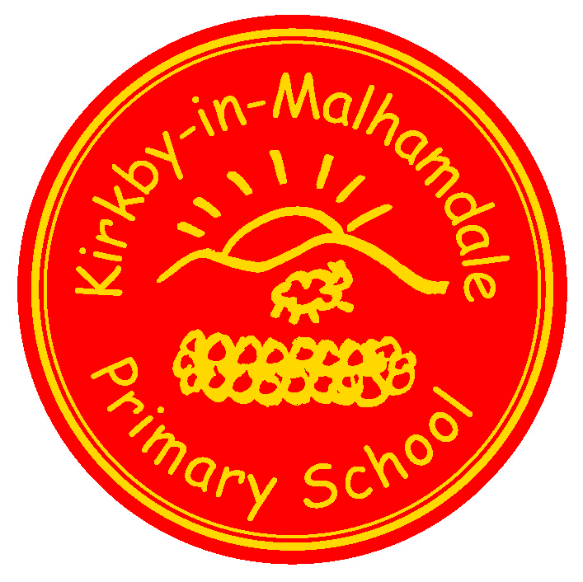
Kirkby-in-Malhamdale United (VA) Primary School,

Kirkby Malham,

Skipton,

North Yorkshire,

BD23 4BY.

Telephone and Fax: 01729 830214
e-mail: admin@kim.n-yorks.sch.uk

Executive Headteacher: Mrs S Peel
NEWSLETTER 3 – 5th October 2017

The newsletter will be issued fortnightly, continuing on a Thursday. This is our main way of communicating, so please take note, and ask questions where you aren’t sure. The next issue will be on Thursday Thurs 9th November.
Craven Schools Cross Country finals at Giggleswick last Thursday was a very successful afternoon with Hance, Alice, Finlay and Anna all qualifying to run for Craven at Dalby Forest in March 2018. Congratulations to all the runners who took part.
Harvest Assembly & Macmillan Coffee Afternoon
We had a lovely afternoon for our Harvest Assembly and Macmillan Coffee Afternoon raising a massive £180.00. Thank you to everyone who came and supported this charity and to all who sent in lovely cakes.
At Harvest assembly the children shared their Harvest work they had done in class. We also sent a huge food hamper to Neville House in Gargrave that had been kindly donated by parents and children. Neville House were extremely grateful and would like to thank everyone who donated.
Year 5/6 Football at Sandylands – Jack writes “There was about 10 teams in the tournament. We only played about 5 teams and we came 5th out of ten altogether. It was a 7-a-side game so we had one substitute. We all played really well and we had a great afternoon”.
Parents Eve – Thank you to everyone for attending our parents evenings. I hope you found them informative and if there are any further questions about your child, please do not hesitate to contact either Mr Bell or Mrs Allen.
After School Club Party - Jessie writes “The after school Halloween party was so much fun. We played really great games such as apple bobbing, musical statues and musical bumps. It was fantastic fun”.
Rudolph Card & Mug Fundraiser – Thank you for sending your Christmas pictures – they have been sent off and will be back in card or mug form as soon as possible. We have made a fantastic £78.20. Well done everyone.
Suggestion Box – There is a wooden suggestion box outside the school office for anyone who would like to make any suggestions or comments about any aspect of school. You can post something at Celebration Assembly on Friday or alternatively send a note with your child.

Christingle Service & School Nativity Play Sunday 10th December 5.30pm
NEWS FROM THE PTA
Christmas Wreath Making Event
The PTA is hosting a Christmas Wreath making event this year on Friday 24th November starting at 7pm. The cost of the ticket is £25 and includes everything you need to make a wreath, mulled wine and mince pies. It should be a great evening with lots of fun to be had! Our very own Sophie Eddleston has agreed to run the event and we all know how beautiful her floral creations are so hopefully we can all
emulate her and come home with something special!
Places are limited so make sure you get your ticket early so as not to be disappointed. Please can you leave cheques (payable to Mrs Sophie Eddleston) or cash with your name and the number of tickets you would like with either the school reception or Victoria Forrow.
We will, as usual be performing our school nativity during the Christingle service in Kirkby Malham Church and would like all the children from school to take part. If you are unable to come, please can you let us know as soon as possible as parts will be given after half term.
Parent Pay - As you will all have gathered now we are starting to use ParentPay straight away after half term for lunch/milk money etc. Any credits/debits for lunches will be entered onto your childs account for you to see when you log into the account. Class One will have no lunches to pay for as they qualify for Universal Free School Meals.
After School Club debits will be added to your account at the month end so either 31st Oct or 1st Nov- we are still using a paper booking form for your completion half termly and will enter onto ParentPay every time your child/children attends for your payment. Please keep checking your account and possibly pay monthly to avoid a large balance building up.
A leaflet was sent out on Tuesday with all the instructions on. Activation letter with your username and password is being sent out tomorrow (Friday) – check your child’s book bag! We are not accepting any cash or cheques in school anymore and hopefully this will be an easier way for both parents and school. A leaflet is attached with all the benefits. If you have any problems with this please let the office know.
Junk Modelling Class One would be very grateful for any used boxes eg. egg boxes, toothpaste boxes etc etc – they are running very short – (not dishwasher or soap power) thank you.
Forthcoming Dates
Fri 20th Oct | 2.45pm Celebration Assembly  3.30pm Half Term Holiday
Mon 30th Oct | 9.00am School Opens
Thurs 2nd Nov | 9.30 – 2.45pm Y5&6 Exploring Religious Diversity at Settle College (details to follow)
Fri 10th Nov | 2.45 pm Celebration Assembly
Thurs 16th Nov | 1.30pm Tempest Photographers to take Children’s Portraits and families  3.15pm youngers siblings for family portraits (details to follow)
Sun 19th Nov | 4.00pm Thanksgiving & Re-Dedication Service in Kirkby Malham Church (details to follow)
Wed 22nd Nov | 11.00am Flu Vaccination Rec – Y4 (unless opted out)
Fri 24th Nov | 2.45pm Celebration Assembly
Sun 10th Dec | 5.30pm Christingle Service and School Nativity in Kirkby Malham Church
Wed 13th Dec | Whole school trip to Pantomime at King George’s Hall, Blackburn – details to follow
Fri 22nd Dec | Christmas Celebration Assembly (time tbc)
 | 3.30pm School closes for Christmas Holidays

