Kirkby-in-Malhamdale United (VA) Primary School,

Kirkby Malham,

Skipton,

North Yorkshire,

BD23 4BY.

Telephone and Fax: 01729 830214
e-mail: admin@kim.n-yorks.sch.uk

Executive Headteacher: Mrs S Peel
NEWSLETTER 5 – 2nd November 2017

The newsletter will be issued fortnightly, continuing on a Thursday. This is our main way of communicating, so please take note, and ask questions where you aren’t sure. The next issue will be on Thursday Thurs 16th November.
Suggestion Box – There is a wooden suggestion box outside the school office for anyone who would like to make any suggestions or comments about any aspect of school. We welcome any comments you would like to make.
Children in Need – Friday 17th November – To celebrate Children in Need Day we are having a non-uniform day. The children should wear (or make) spotty clothing and bring minimum £1.00 cash donation for this very worthwhile cause.
Sunday 19th November at 4.00 pm
Kirkby Malham Church are holding a service of Thanksgiving and Rededication following the extensive works on the church and everyone is invited. Mrs Ellis runs a recorder group at school and is hoping that if they are able to attend they could take part in the service. Any other children attending the service will also be involved in a musical way during the ‘Sing Hosanna’ hymn. Hope to see you there.
Christingle Service & School Nativity Play Sunday 10th December 5.30pm

We will, as usual be performing our school nativity during the Christingle service in Kirkby Malham Church and would like all the children from school to take part. If you are unable to come, please can you let us know as soon as possible as parts will be given after half term.
Parent Pay - ParentPay is up and running and hopefully everyone has now logged on and changed their password to start using the system for their child/children’s lunch, milk, After School Club etc. We hope this will all run smoothly with less work for both parents and school. Shortly we will be adding our whole school pantomime trip and will email parents regarding arrangements and payment.
Junk Modelling Class One would be very grateful for any used boxes eg. egg boxes, toothpaste boxes etc etc – they are running very short – (not dishwasher or soap power) thank you.
Outdoor PE Kit – As the weather gets colder can you ensure the children have warm PE kit. Joggers and fleece/hoodies are a good idea with socks for the girls who wear tights.
Headlice in School – we have been informed that headlice is in school again. Please do check your children and the whole family as soon as possible and only send children to school if they have been treated.
Halloween Party at The Victoria – A family Halloween Party was held at the Victoria, Kirkby Malham at the weekend from which Gemma and Chris donated £58.00 to school from the proceeds. We thank them very much indeed and will put the money towards an ice cream or lolly for each child at the pantomime on the 13th December.

Poppy Appeal – we are selling poppies and accessories in school next week if you would like to send a donation for the British Legion.
NEWS FROM THE PTA
Christmas Wreath Making Event
The PTA is hosting a Christmas Wreath making event this year on Friday 24th November starting at 7pm. The cost of the ticket is £25 and includes everything you need to make a wreath, mulled wine and mince pies. It should be a great evening with lots of fun to be had! Our very own Sophie Eddleston has agreed to run the event and we all know how beautiful her floral creations are so hopefully we can all
emulate her and come home with something special!
Places are limited so make sure you get your ticket early so as not to be disappointed. Please can you leave cheques (payable to Mrs Sophie Eddleston) or cash with your name and the number of tickets you would like with either the school reception or Victoria Forrow.
PTA Annual General Meeting
This will be held at school on Thursday 9th November in the hall at 7.00 pm
Carys has been 'passing on her passion' sporting baton to our sports coach Sam.
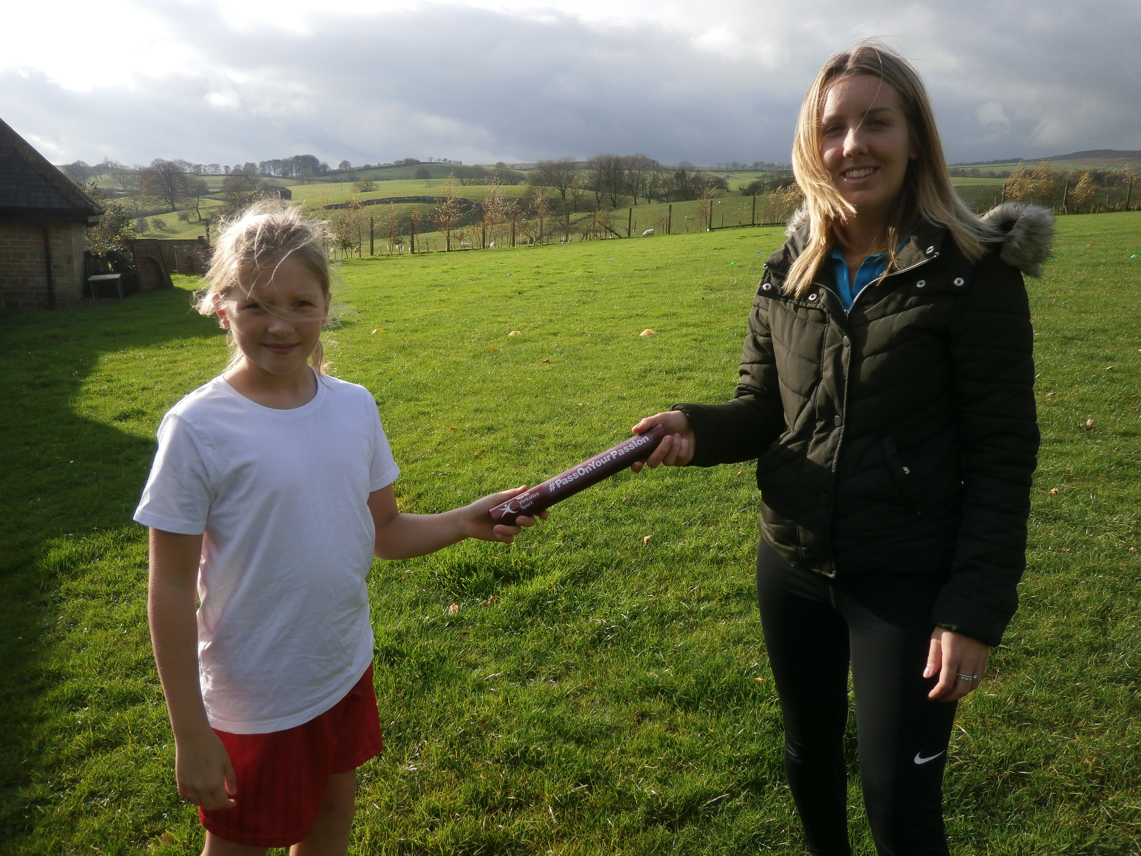
In 2017 North Yorkshire Sport are championing the #PASSONYOURPASSION campaign which takes place across the whole of the North of England, to celebrate the hard work of inspirational female coaches in sport and encourage the next generation to get involved.
Sam was really pleased to receive the baton from Carys - who has a passion for lots of sports, especially swimming, and said she would be passing the baton on to a female pupil in another school who is as a passionate about sport as Carys and herself.

Mon 30th Oct | 9.00am School Opens
Thurs 2nd Nov | 9.30 – 2.45pm Y5&6 Exploring Religious Diversity at Settle College
Thurs 9th Nov | 7.00pm PTA AGM in school hall
Fri 10th Nov | 2.45 pm Celebration Assembly
Thurs 16th Nov | 1.30pm Tempest Photographers to take Children’s Portraits and families  3.15pm youngers siblings for family portraits (details to follow)
Fri 17th Nov | Children in Need Non Uniform Day – Spotty clothing and £1.00 donation
Sun 19th Nov | 4.00pm Thanksgiving & Re-Dedication Service in Kirkby Malham Church – everyone welcome
Wed 22nd Nov | 11.00am Flu Vaccination Rec – Y4 (unless opted out)
Fri 24th Nov | 2.45pm Celebration Assembly  7.00 pm Christmas Wreath Workshop – Tickets £25 (available at school)
Sun 10th Dec | 5.30pm Christingle Service and School Nativity in Kirkby Malham Church
Wed 13th Dec | Whole school trip to Pantomime at King George’s Hall, Blackburn – details to follow
Fri 22nd Dec | Christmas Celebration Assembly (time tbc)
 | 3.30pm School closes for Christmas Holidays

CHRISTMAS CLUB!!
Dear Parents,
I am proposing to run a Christmas Club after half term. The club will involve lots of activities related to Christmas - cookery and crafts etc. It will run on Mondays after school from 3.30 – 5pm. The cost of this club will be £1.50 per child to cover costs of materials/food etc. They will also get a drink and a snack – biscuit or fruit. (£9 for the six weeks and cash please.)
Regular After School club children that want to attend will have their tea after 5pm. (normal price applies no extra £1.50)
The dates of the club are November 6th,13, 20, 27th and December 4th and 11th. No club first and last week of half term.
Please fill in the slip below if you would like to attend. Slips must be back by Friday 3rd Nov.
Regards
Amanda Allen

___________________________________
Name ___________________________
would love to stay to the amazing Christmas Club!
Signed ________________

