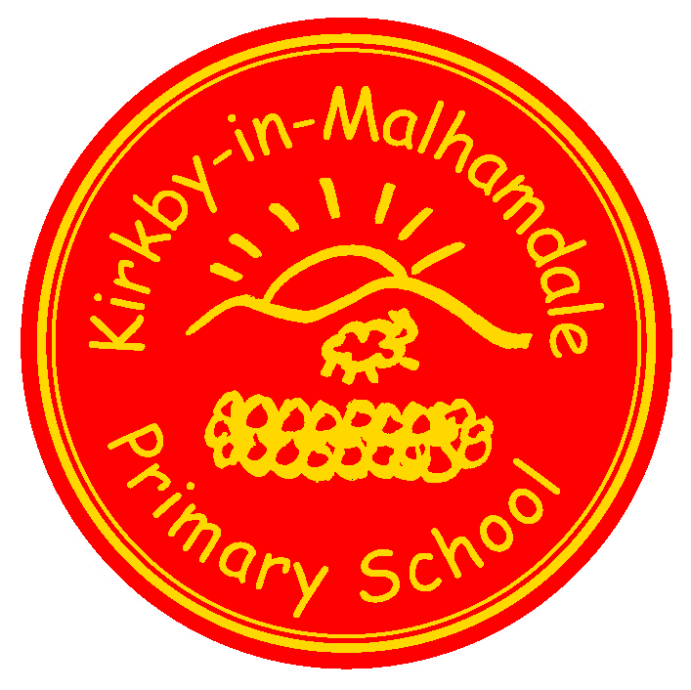
Kirkby-in-Malhamdale United (VA) Primary School,

Kirkby Malham,

Skipton,

North Yorkshire,

BD23 4BY.

Telephone and Fax: 01729 830214
e-mail: admin@kim.n-yorks.sch.uk

NEWSLETTER 10 25th January 2018 Interim Headteacher: Mrs A. Allen
The next Newsletter will be issued on Thursday 8th February

 | Certificates-General Achievement and Writer of the Week | KiM
Class 1 | Connie, Charlotte, Ruby, Ben, Harry E and James | Lucy
Class 2 | Alice, Rhiannon, Hallam, Katy | Barnes

School Weekly Swimming at Settle Pool – Our weekly swim is going very well, please remember your child’s swimming kit every Thursday.
Craven Swimming Gala – Finlay, Jack, Thomas, Alice, Madeline, Jessie, Carys, Katy, Fraiser, Oliver, Sophie, Anna, Rafe and John all took part in the Craven Schools Swimming Gala last Thursday of which 9 children got through to the finals. All children swam amazingly well racing against some very strong swimmers from larger Skipton schools. Sadly no one is through to the Craven Gala Finals. Well done to all swimmers.
Playmaker Training at Carleton School – Five Y6 children went to Carleton Primary School on Tuesday to train how to become playground leaders. All enjoyed themselves and were great role models for school.
New Children - We warmly welcome Dylan and Lacey to our school. They have both settled in very well.
Y6 London Trip – Monday 29th January – The Y6 children are thoroughly looking forward to their day in London this Monday which includes a packed day visiting The Houses of Parliament, Horse Guard’s Parade, 10 Downing Street and a walk to Buckingham Palace. Please remember packed breakfast and lunch, tea will be provided. You will receive brief updates of the children’s whereabouts during the day via email. If anyone has any problems getting their child to Skipton Railway Station for 6.30am, please let us know.
CEOP Child Exploitation & Online Protection Assembly for Parents – on Tuesday 30th January at 9.15 am PC Emily Hewitson from Grassington Police will deliver a 20 minute assembly for parents. Please visit the website www.thinkuknow.co.uk which includes age related videos of all the dangers on the internet. All parents are invited to come and listen, after which the children will have an assembly to make them aware of the dangers. This is part of our School Safeguarding policy.
The Cameo (Come and Meet Each Other) Club (formally Over 60’s) are in school on Monday 19th February in the afternoon when Liz and Patrick Wherity will deliver a talk for the Club and the children regarding a charity they support in Nepal which are building a school for primary aged children. After the talk they will enjoy tea and refreshments served by the children.
Whole School Tennis Coaching – after half term Adam Cox from Skipton Tennis Centre will be delivering 12 sessions of tennis for the whole school on Tuesday mornings split into 3 sessions. This will carry on for the first half of the Summer Term. The children do not need tennis rackets but can bring their own if they want to.

Fire Safety Education – on Monday 26th February Daniel Szeplaki will deliver a fire safety assembly for the whole school.
Parents Reading Assembly to take place before Celebration Assembly on Friday 2nd March at 2.15 pm to include information about Accelerated Reader, reading standards expected for your children and reading in school – please come and join us.
NSPCC Safeguarding ‘Speak Out and Stay Safe’ Assembly to take place on Monday 5th March for Class 1 and 2 separately with a workshop for Y5/6 after break. A letter will be sent out before the event.
Junk Modelling - Class 1 are low on junk modelling so any cardboard boxes you can send in would be appreciated (not dishwasher or soap power please)
School Uniform – We have been informed by our suppliers MC Sports that uniform is available to order online at http://www.mcsports.org.uk/kirkby-malham-primary-school/
You can also ring Mike on 01756 791688 or email him at mcsportsonline@gmail.com
Holiday Dates 2018/19 Attached is a holiday dates list for this year and next.

Diary Dates
Mon 29th Jan | Y6 London Trip
Tues 30th Jan | 9.15 am Parents Internet Safety Training Assembly (20 mins)  Followed by Children’s Internet Safety Training
Fri 2nd Feb | 2.45 pm Celebration Assembly
Fri 9th Feb | 3.30 pm Half term holiday
Mon 19th Feb | 9.00 am School Opens
Mon 19th Feb | 1.00 pm CAMEO Club – Talk on Nepal
Tues 20th Feb | 9.30am – 11.30am Tennis Coaching with Adam Cox (for 12 weeks)
Mon 26th Feb | 9.30 am Fire Safety Education Assembly
Fri 2nd March | 2.15 pm Parents Reading Assembly  2.45 pm Celebtration Assembly
Mon 5th March | 9.30 am Speak Out and Stay Safe Assembly for children
Friday 16th March | 2.45 pm Celebration Assembly
Sat 17th March | PTA Ball at Coniston Hotel – details to follow

Safeguarding Notice
Kirkby-in-Malhamdale United V.A Primary School is committed to ensuring the welfare and safety of all children in school. All North Yorkshire schools, including Kirkby-in-Malhamdale Primary School, follow the North Yorkshire Safeguarding Children Board procedures. The school will, in most circumstances, endeavour to discuss all concerns with parents about their child/ren. However, there may be exceptional circumstances when the school will discuss concerns with Social Care and/or the Police without parental knowledge (in accordance with Child Protection procedures). The school will, of course always aim to maintain a positive relationship with all parents. The school’s child protection policy is available in the policies section of the web site.

