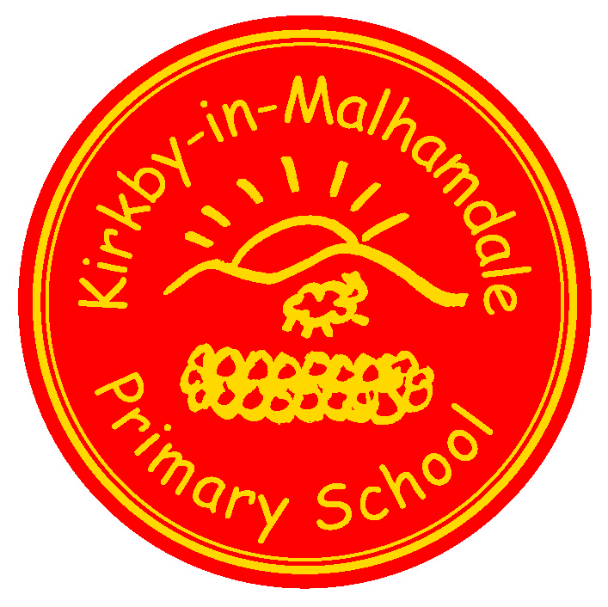
Kirkby-in-Malhamdale United (VA) Primary School,

Kirkby Malham,

Skipton,

North Yorkshire,

BD23 4BY.

Telephone and Fax: 01729 830214
e-mail: admin@kim.n-yorks.sch.uk

Interim Headteacher: Mrs A. Allen

NEWSLETTER 11 - 8th February 2018
The next Newsletter will be issued on Thursday 22nd February

 | Certificates - General Achievement and Writer of the Week | KiM
Class 1 | Rubyann, Edward, Lucy, Betsy, Connie, Benjamin, Mia and Daisy. | Elliot
Class 2 | Jack, William, Preston, Anna, Sophie | Thomas

School Weekly Swimming at Settle Pool – Our weekly swim is going very well, please remember your child’s swimming kit every Thursday.
Y6 London Trip – Monday 29th January – The Y6 children enjoyed an action packed day in London visiting The Houses of Parliament, Horse Guard’s Parade, 10 Downing Street and a walk to Buckingham Palace. CEOP Child Exploitation & Online Protection Assemblies – on Tuesday 30th January PC Paul Stephenson, PCSO Emily Hewitson and PCSO Lee Brittain delivered an assembly for parents. Which was well attended. We hope this was useful for parents. The children then took part in their own assemblies where the importance of keeping safe when online was taught. For further information our school website, on the Safeguarding section has lots of useful links to sites to help you keep your children safe online. The website www.thinkuknow.co.uk includes age related videos of all the dangers on the internet.
The Cameo (Come and Meet Each Other) Club (formally Over 60’s) are in school on Monday 19th February in the afternoon when Liz and Patrick Wherity will deliver a talk for the Club and the children regarding a charity they support in Nepal which is building a school for primary aged children. After the talk tea and refreshments will be served by the children.
Whole School Tennis Coaching – after half-term Adam Cox from Skipton Tennis Centre will be delivering 12 sessions of tennis for the whole school on Tuesday mornings split into 3 sessions. This will carry on for the first half of the Summer Term. The children do not need tennis rackets but can bring their own if they want to.
Fire Safety Education – on Monday 26th February Daniel Szeplaki will deliver a fire safety assembly for the whole school. This encourages children to think about the dangers of fire but also to encourage children what to do in the event of a fire.
Parents Reading Assembly to take place before Celebration Assembly on Friday 2nd March at 2.15 pm to include information about Accelerated Reader, reading standards expected for your children and reading in school – please come and join us.

NSPCC Safeguarding ‘Speak Out and Stay Safe’ Assembly to take place on Monday 5th March for Class 1 and 2 separately with a workshop for Y5/6 after break. You should have received a letter giving further information.
Junk Modelling - Thank you for donations of cardboard boxes for Class 1 junk modelling. More would be appreciated (though not dishwasher or soap power please)
School Uniform – We have been informed by our suppliers MC Sports that uniform is available to order online at http://www.mcsports.org.uk/kirkby-malham-primary-school/
You can also ring Mike on 01756 791688 or email him at mcsportsonline@gmail.com
ParentPay - New lunch balances will be added to your ParentPay account for the next half of term. Please settle outstanding lunch debts as soon as possible. Also Group of 8 Music children’s payments have been added. There will be 5 lessons before the end of term with Mr Waugh for those concerned.

Half-term – starts tomorrow afternoon, Friday 9th February. Have a lovely week off and see you all back on Monday 19th February.

Diary Dates
Friday 9th Feb | 3.30 pm Half term holiday
Monday 19th Feb | 9.00 am School Opens
Monday 19th Feb | 1.00 pm CAMEO Club – Talk on Nepal
Tuesday 20th Feb | 9.30am – 11.30am Tennis Coaching with Adam Cox (for 12 weeks)
Monday 26th Feb | 9.30 am Fire Safety Education Assembly
Friday 2nd March | 2.15 pm Parents Reading Assembly  2.45 pm Celebration Assembly
Monday 5th March | 9.30 am Speak Out and Stay Safe Assembly for children
Friday 16th March | 2.45 pm Celebration Assembly
Saturday 17th March | PTA Ball at Coniston Hotel – details to follow
Thursday 22nd March | Cross Country finals in Dalby Forest.
Thursday 29th March | 3.30pm Start of Easter holiday

Safeguarding Notice
Kirkby-in-Malhamdale United V.A Primary School is committed to ensuring the welfare and safety of all children in school. All North Yorkshire schools, including Kirkby-in-Malhamdale Primary School, follow the North Yorkshire Safeguarding Children Board procedures. The school will, in most circumstances, endeavour to discuss all concerns with parents about their child/ren. However, there may be exceptional circumstances when the school will discuss concerns with Social Care and/or the Police without parental knowledge (in accordance with Child Protection procedures). The school will, of course always aim to maintain a positive relationship with all parents. The school’s child protection policy is available in the policies section of the web site.

