Kirkby-in-Malhamdale United (VA) Primary School,

Kirkby Malham,

Skipton,

North Yorkshire,

BD23 4BY.

Telephone and Fax: 01729 830214
e-mail: admin@kim.n-yorks.sch.uk

Interim Headteacher: Mrs A. Allen

NEWSLETTER 13 - 22nd March 2018
The next Newsletter will be issued on 26th April
n
 | Certificates - General Achievement and Writer of the Week | KiM
Class 1 | Harry H, Flynn and Ruby | Aimee
Class 2 | Rhiannon, Katy and Sophie | Preston

Whole School Tennis Coaching – Tennis coaching is going very well with Adam Cox from Skipton Tennis Centre and will continue until May half term.
Junk Modelling - Thank you for donations of cardboard boxes for Class 1 junk modelling. More would be appreciated (though not dishwasher or soap powder please)
ParentPay - Thank you for all your payments for various items to ParentPay, please keep checking your account and make payments as regularly as possible.
We are endeavouring to make sure After School Club payments are settled before the end of each month so we can start afresh for the new month.
It’s our financial year end on 31st March and it would be really helpful if all outstanding payments were made by that date. Thank you.

Crucial Crew
On Monday, 19 March, Y6 accompanied by Mrs Rushton went to Eshton Grange Playaway Centre, Gargrave to take part in the annual Crucial Crew Youth Event organised by North Yorkshire Police. The event is designed to educate Y6 pupils to make informed decisions when faced with danger and respond effectively to emergency situations and accidents. Children rotate around ten, 10 minute scenarios based on the theme ‘Keeping Safe’ and including fire safety, water safety, drug awareness, internet safety, electric safety, alcohol and anti-social behaviour, rural countryside dangers and safety.
Mrs Rushton reports that our Y6 were fantastically well-behaved, totally engaged and participated fully in all the scenarios. Also Jessie won a prize in the poster competition. A very good day all round!

Quicksticks Hockey
Year 3 and 4 children took part in the Quicksticks hockey tournament on Monday and we came away with some fantastic results. We played in three teams and got silver and bronze medals for two of the teams. The other team narrowly missing out on bronze. We lost in the final 1-0 to Greatwood, but it was good match with determination to win and brilliant sportsmanship. We now qualify to take a team to play in the Small Schools quicksticks event in May.

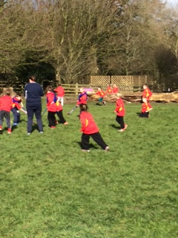
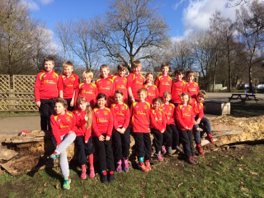

Duathlon
The duathlon ‘SpacetoEarth’ organised by the School Sports Partnership was a brilliant event. The event took place at Gargrave Primary School and their school hall was filled with bikes on rollers. The aim was to cycle for two minutes then run for two minutes round the playground then rest for two minutes, doing this for half an hour. All the laps and cycling was measured and at the end of the session the group
(80 children) had completed 330km, which was literally just under half way to the space station. This was a fantastic event that the children all enjoyed and took part in with a smile on their face. Special mention to Lisa who will receive a pin badge for her determination. She was chosen from the 80 children to have shown the most effort and sporting spirit – well done Lisa.

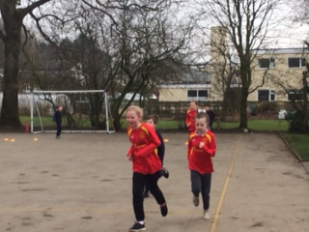
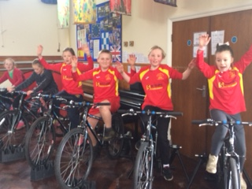
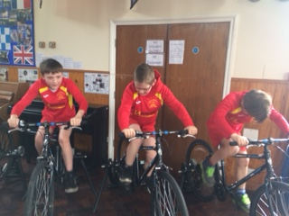

Well done Y5 and 6! Brilliant Duathletes!

Hot off the press! – Results from the Cross Country Finals at Dalby Forest
As mentioned previously we had four children who qualified to run for Craven in the North Yorkshire finals today at Dalby Forest near Pickering and the results are just in ….
Finley ran for Y6 Boys and came 7th, Hance ran for the inclusion race and came 6th, Anna ran for Y4 Girls and came 19th and Alice ran for the Y3 Girls and came 13th.
These are incredible results considering there were over 580 children who took part altogether so a huge congratulations to our four children – we are very proud of you.

New Door- As most of you will have seen we now have a new secured door past the school office. This enables us to safeguard your children more effectively. If you need to bring your child into school, please could you leave them at our new door. Thank you for your cooperation.
Diary Dates
Thursday 22nd March | Cross Country finals in Dalby Forest.  Last Swimming Lesson  Parents Evening (2)
Tuesday 27th March | 3.00pm Music Concert with Mr Waugh for Parents
Thursday 29th March | 2.45pm Celebration Assembly
 | 3.30pm Start of Easter holiday
Tuesday 17th April | 9.00am School Opens for Summer Term  9.30 am – Tennis with Adam Cox
Monday 23rd April | 1.15 – 2.45 pm Tag Rugby each Monday for Class 2 with Hedley Verity from Wharfedale RUFC
Friday 27th April | 2.45 pm Celebration Assembly
Monday 7th May | School closed. May Day Holiday
Friday 11th May | 2.45 pm Celebration Assembly
Friday 25th May | 2.45 pm Celebration Assembly  3.30 pm Summer Half Term

PE – please can you ensure that all children are fully equipped for outdoor PE. Joggers, warm top and trainers. Thank you.

School Uniform – We have been informed by our suppliers MC Sports that uniform is available to order online at http://www.mcsports.org.uk/kirkby-malham-primary-school/
You can also ring Mike on 01756 791688 or email him at mcsportsonline@gmail.com

Safeguarding Notice
Kirkby-in-Malhamdale United V.A Primary School is committed to ensuring the welfare and safety of all children in school. All North Yorkshire schools, including Kirkby-in-Malhamdale Primary School, follow the North Yorkshire Safeguarding Children Board procedures. The school will, in most circumstances, endeavour to discuss all concerns with parents about their child/ren. However, there may be exceptional circumstances when the school will discuss concerns with Social Care and/or the Police without parental knowledge (in accordance with Child Protection procedures). The school will, of course always aim to maintain a positive relationship with all parents. The school’s child protection policy is available in the policies section of the web site.

