Kirkby-in-Malhamdale United (VA) Primary School,

Kirkby Malham,

Skipton,

North Yorkshire,

BD23 4BY.

Telephone and Fax: 01729 830214
e-mail: admin@kim.n-yorks.sch.uk

Interim Headteacher: Mrs A. Allen

NEWSLETTER 15 - 10th May 2018
The next Newsletter will be issued on 24th May

 | Certificates - General Achievement and Writer of the Week | KiM
Class 1 | Daisy and Harry H | Edward
Class 2 | Carys, Barnes, Alice, Finlay, Joshua | Matthew

Whole School Tennis Coaching – Tennis coaching is going very well with Adam Cox from Skipton Tennis Centre and will continue until May half term. Like last year we are going to watch professional tennis players play at Ilkley Tennis Club in June. Details to follow. The next two sessions are on Friday, not Tuesday.
Tag Rugby with Hedley Verity from Wharfedale RUFC – Class 2 are having weekly tag rugby training on a Monday afternoon in preparation for tournaments for Y3/4 and Y5/6 later in the term. Please remember to send warm PE clothing as they will be outside unless it’s raining heavily.
PE with Sam Pickard – Sam from SELFA continues to deliver PE for the whole school on a Wednesday afternoon – the same applies with warm joggers and hoodies if it’s cold.
Junk Modelling - Thank you for donations of cardboard boxes for Class 1 junk modelling. More would be appreciated (though not dishwasher or soap powder please)
ParentPay - Please can everyone check their ParentPay accounts for lunches, ASC and Group 8. There are a lot of debts for lunches and After School Club that need settling as soon as possible please.
Madeleine Lindley Trip – Sophie writes ‘It was amazing and very big, but not as big as a maze. I really enjoyed reading the books, it was really interesting. We chose lots of books and took with us everyone’s sheet that had their choice of book on. I hope we bought what everyone wanted’. The books have just arrived and the children who went on the trip have been helping unpack them. They are very excited to get reading as soon as possible!

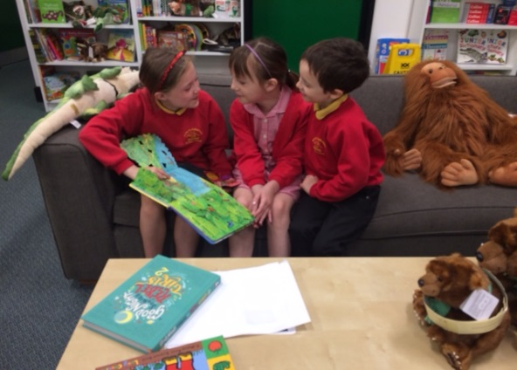

Y5/6 Tennis Tournament at Skipton Tennis Centre - Carys writes ‘Tennis was extremely fun, I played in four matches and I won half of them. It was a really fun time, I was playing alongside Rhiannon, Katy, Jessie, Fraiser, Finlay, Jack and Alfie. It was epic’.
Y3/4 Tennis Tournament at Skipton Tennis Centre – Rafe writes ‘Tennis on Tuesday was great fun, me, Ben, Alice and Anna were in the A team and John, Hallam, Madeline and Sophie were in team B. Mrs Allen gave us numbers for the different numbered courts. My first match was against a boy who sadly beat me. The other matches were against girls, they were no match for me! The A team got in the semi finals and then the final that was against Water Street – Yay, we won!’ The A team (Rafe, Ben, Alice and Anna) will play in the finals at Skipton Tennis Centre on Tuesday 22nd May – we wish them all masses of luck.

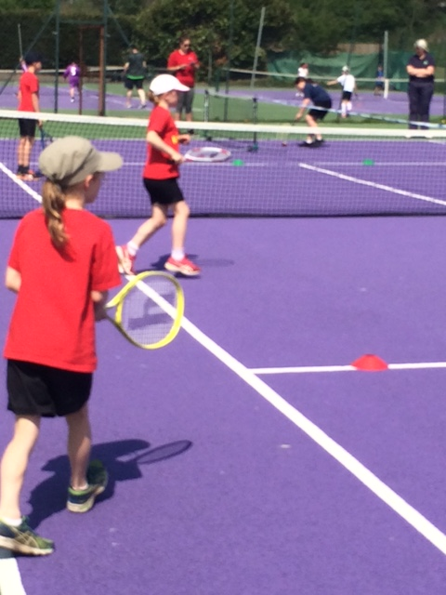

KS2 & KS2 Strictly Come Dancing Festivals – Both classes are taking part on two separate dates with Howard of Fire House Dance at The Skipton Academy. This is not a competition but a fun dance session. Please send your permission slips in asap – thank you.
Sports Day – Sports Day will be on Thursday 21st June in the afternoon – time to be confirmed. Reserve Sports Day if bad weather will be on Friday 22nd June.
Assessments – May is a very busy month for statutory assessments (SATS) for Y2 and Y6. Y2 SATS take place during the month of May and Y6 SATS take place the week beginning 14th of May. We minimise everything that is going on in school in the Y6 SATS week mornings to create a quieter less disruptive environment. We want to give the children the best chance to succeed so they feel they have done their best. They are working hard and we are very proud of them.
Parking – many thanks to all those that are leaving space for the bus on a morning, it is vital that the children have a safe route off the bus straight into school. Although the school gates were open for the last celebration assembly not many people parked on the playground and once again the school car park became grid locked and the bus could not get in off the road. Please can the playground be used tomorrow to avoid this congestion. Please note that parking 2 abreast by the wall does not allow the bus enough room to draw into the car park. By all means block the teachers’ cars in. We appreciate your help with this matter. The governors are looking at the matter and hopefully this will be resolved. Safeguarding is our top priority!
Celebration Assembly – Please note there will not be a Celebration Assembly on Friday 25th May. The next one will be after half term on Friday 8th June.
PTA Meeting tomorrow at 2pm in our new library.

Diary Dates
Friday 11th May | 2.45 pm Celebration Assembly
Monday 14th May | SATs Week – no music or morning sport lessons this week  1.00pm Y1 Playground Games at Sandylands
Tuesday 15th May | 1.45 pm KS1 Strictly Come Dancing Festival at Skipton Academy
Friday 18th May | 9.30am Adam Cox Tennis
Tuesday 22nd May | 1.00pm Year 3 and 4 Tennis finals at Skipton Tennis Centre  1.45 pm KS2 Strictly Come Dancing Fesitval at Skipton Academy
Friday 25th May | 9.30 – 11.30 am Final Tennis session for whole school  3.30 pm Summer Half Term
Monday 4th June | 9.00 am School opens
Tuesday 5th June | Whole school Cricket (6 weekly sessions) with Anthony Bradley, Settle Cricket Club
Thurs June 7th | 1.00 pm Y4 Boys Cricket at Skipton Cricket Club – details to follow
Monday 11th June | 1.00 pm Y3 and 4 Quad Athletics (details to follow)
Wed 20th June | 11.30 – Whole school to Ilkley Tennis Club for workshop and watching professionals
Thurs 21st June | Pm – Sports Day
Friday 22nd June | 11.00 am Tempest Photographers to take whole school photo
Wed 27th June | 1.00 pm Tag Rugby Tournament at Skipton – details to follow
Thurs 28th June | 1.00 pm New Entrants transition afternoon (1)
Thurs 5th July | 12.00 noon New Entrants transition afternoon plus lunch (2)
Thurs 12th July | 9.00 am New Entrants transition day (3)
Wed 18th July | 6.30 pm School Play at Victoria Hall, Settle
Friday 20th July | 9.30 – 11.30 am Adam Cox for whole school tennis  Leavers Assembly (time to be confirmed)  3.30 pm End of term

PE – please can you ensure that all children are fully equipped for outdoor PE. Joggers, warm top and trainers and that they are labelled correctly too. Thank you.

School Uniform – We have been informed by our suppliers MC Sports that uniform is available to order online at http://www.mcsports.org.uk/kirkby-malham-primary-school/
You can also ring Mike on 01756 791688 or email him at mcsportsonline@gmail.com

Safeguarding Notice
Kirkby-in-Malhamdale United V.A Primary School is committed to ensuring the welfare and safety of all children in school. All North Yorkshire schools, including Kirkby-in-Malhamdale Primary School, follow the North Yorkshire Safeguarding Children Board procedures. The school will, in most circumstances, endeavour to discuss all concerns with parents about their child/ren. However, there may be exceptional circumstances when the school will discuss concerns with Social Care and/or the Police without parental knowledge (in accordance with Child Protection procedures). The school will, of course always aim to maintain a positive relationship with all parents. The school’s child protection policy is available in the policies section of the web site.

