Kirkby-in-Malhamdale United (VA) Primary School,

Kirkby Malham,

Skipton,

North Yorkshire,

BD23 4BY.

Telephone and Fax: 01729 830214
e-mail: admin@kim.n-yorks.sch.uk

Interim Headteacher: Mrs A. Allen

NEWSLETTER 18 – 28th June 2018
The next Newsletter will be issued on 12th July

 | Certificates - General Achievement and Writer of the Week | KiM
Class 1 | Amy, Elliot, Mia, Archie | Connie
Class 2 | Preston, Thomas, Madeline, Rafe, Fraiser, James, Victoria | Alice

Tonight 3.30 – 4.30 pm Parental Chat with Mr Richard Wright – please don’t forget that Mr Wright, our Executive Headteacher from September will be here to talk to parents tonight between 3.30 – 4.30 pm.

Morning School – An increasing number of children are being dropped off at school early when there is no member of staff outside. Please can you come between 8.40 am and 9.00 am when a member of staff will be on duty – thank you.
Facebook – Hopefully in the next few days we are launching a Facebook page, however we cannot do this until everyone has signed the Use of Photo and Images for school purposes attached which includes School Facebook Site – please sign as soon as possible and return to school.
Parental Response Form – If anyone still has a competed response form for Mr Richard Wright, please can it be returned as soon as possible.
Thank you for your support with the parking in school at busy times. Parking on the field at assembly last week proved very efficient and allowed the children safe access to the bus and for you to take your children safely to your car. Please continue to do this for assemblies and sports afternoon.
Our six near starters are coming to their first of three transition days today and we are looking forward to welcoming them to our lovely school.
School Play The children are working hard learning the songs and lines for the school play. Please can you help them ‘rehearse’ their lines at home as much as possible, they may sing to you too without giving too much away!! They will need to bring the script to school every day. Thanks. On play day Wednesday 18th July, please can you take your child/children straight to Victoria Hall, Settle for 9.00am for rehearsals and collect at 3.30 pm. They then need to be back at Victoria Hall for 6.00pm at the latest. They will need to bring a packed lunch plus drinks and a snack. If there are any problems at all with getting your child to and from Settle, please let us know.
TICKETS ARE AVAILABLE ON PARENT PAY – PLEASE ORDER AS SOON AS POSSIBLE!
Whole School Tennis Coaching – Adam Cox has now finished his tennis coaching for this term except for a ‘special’ lesson on the last day of term which should be lots of fun for everyone.
ParentPay - Please can everyone check their ParentPay accounts for lunches, ASC and Group 8. All are added via a daily register system so please keep looking as there are many unpaid debts which must be settled by the end of the term.

The latest sporting events taken place are as follows:-
Ilkley Tennis Trip – Rhiannon writes ‘On the 20th June 2018 the whole school went to Ilkley Tennis Centre at 11.30 am. We got on a big bus and set off. I sat next to Maddie and played I Spy. When we got there the weather was quite miserable but we still had fun. After a few minutes of waiting we finally went on the tennis courts and played different activities. After lunch everyone went to watch some professionals play. I enjoyed it because everyone’s eyes were following the ball also the sun finally came out. I had a really good day and all of us enjoyed it’.

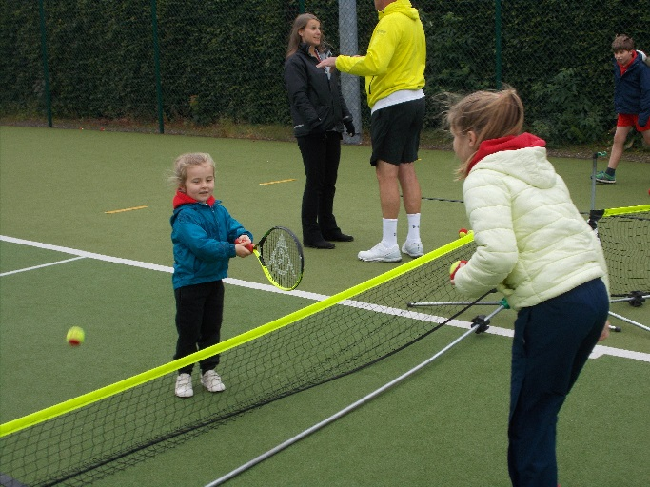

Sports Day – Katy writes ‘On Thursday 21st June 2018, after lunch, we had Sport’s Day. There were three teams, Ash, Oak and Fir. I was in Fir. It was very warm on that day so we all had to keep hydrated. My favourite race was the relay race because we all worked as a team and had fun. Sadly we didn’t win the relay but I’m definitely looking forward to seeing the results’.
Y3/4 Tag Rugby at Sandylands – John writes ‘On a very hot Wednesday we were playing Tag Rugby and we had two teams of nine with a sub. We played Water Street, Bradley, Gargrave, St Stephens and Greatwood. The team I was in wiped the board and won them all!! Our other team did very well too with a win, a lose and the rest a draw’.

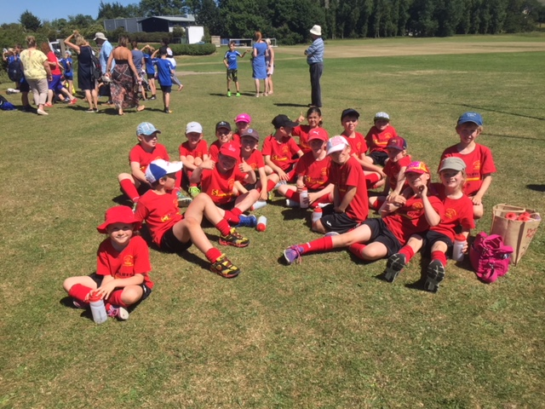

Music Concert – On Tuesday 3rd July the whole school will be performing in a music concert with Mr Waugh at 3.00 pm – everyone welcome. Unfortunately Mr Waugh is retiring at the end of this term and we wish him all the best in his retirement.

From September, we will not be having weekly music lessons or group of eight. The private music lessons will be carrying on as normal and if anyone would like details and prices of these lessons please ask Mrs Milner/Mrs Eccles ton for a leaflet from County Music Service. All the instruments that Class 2 have been playing on a Tuesday afternoon in the WOP will need bringing back to school before they are collected on Friday 13th July.
Governors – please look on our school website on the Governor section to familiarise yourselves with our school's Governing Body. We have also created a new PTA page, which is under the Parents tab on the top task bar on the website too.

Diary Dates
Thurs 28th June | Ermysteds/SGHS/UWS Transition Day  1.00pm New children transition afternoon (1)  3.30 – 4.30pm Parental chat with Mr Richard Wright
Mon 2nd July | Y6 Transition Day at Ingleborough Hall – details to follow
Tues 3rd July | 3.00 pm – Mr Waugh’s Music Concert for parents
Fri 6th July | 2.45pm Celebration Assembly
Thurs 5th July | 12.00 noon New Entrants transition afternoon plus lunch (2)
Mon 9th July | 3.30 – 6.00 pm After School Club Summer Party
Wed 11th July | Y6 Settle College Transition Day
Thurs 12th July | 9.00 am New Entrants transition day (3)
Fri 13th July | 10.30 am Skipton Library Visit Assembly – Summer Reading Challenge
Mon 16th July | 9.00 am Whole School Day out to Eshton Grange
Wed 18th July | 9.00 am Children to Victoria Hall Settle all day rehearsing (no school bus)  6.30 pm School Play at Victoria Hall, Settle
Friday 20th July | 9.30 – 11.30 am Adam Cox for whole school tennis  Leavers Assembly (time to be confirmed)  3.30 pm End of term
PE – please can you ensure that all children are fully equipped for outdoor PE. Joggers, warm top and trainers and that they are labelled correctly too. Thank you.
School Uniform – We have been informed by our suppliers MC Sports that uniform is available to order online at http://www.mcsports.org.uk/kirkby-malham-primary-school/
You can also ring Mike on 01756 791688 or email him at mcsportsonline@gmail.com
GDPR – Privacy Notice for Parents and Pupils
The latest Privacy Notice for Parents and Pupils can be seen on our school’s website under Statutory Information
Safeguarding Notice
Kirkby-in-Malhamdale United V.A Primary School is committed to ensuring the welfare and safety of all children in school. All North Yorkshire schools, including Kirkby-in-Malhamdale Primary School, follow the North Yorkshire Safeguarding Children Board procedures. The school will, in most circumstances, endeavour to discuss all concerns with parents about their child/ren. However, there may be exceptional circumstances when the school will discuss concerns with Social Care and/or the Police without parental knowledge (in accordance with Child Protection procedures). The school will, of course always aim to maintain a positive relationship with all parents. The school’s child protection policy is available in the policies section of the web site.

