Kirkby-in-Malhamdale United (VA) Primary School,

Kirkby Malham,

Skipton,

North Yorkshire,

BD23 4BY.

Telephone and Fax: 01729 830214
e-mail:admin@kim.n-yorks.sch.uk

Executive Headteacher: Mr Richard Wright

NEWSLETTER 13 Spring Term w/c 08/05/19

The last three week’s Captain’s Table were as follows:
29.03.19: James E, Thomas S, Maddie, Ben P, Frank, William, Katy, Elliot, Preston
05.04.19: Daisy, Charlie, Pippa, Flynn, Rafe, Lucy, Hallam, Lacey, Jacob

KiM Winners: Class 3 - Hallam Class 2 - Lucy Class 1 - Abigail
Congratulations to everyone mentioned above and keep up the good work.

Class 2 Trip to Bradford Museum – As part of their science work Class 2 had a very enjoyable trip to Bradford Science Museum where they took part in a Light Workshop, creating their own galaxy. They explored the museum and watched a fascinating firm on eye dissection (sheep not human!)

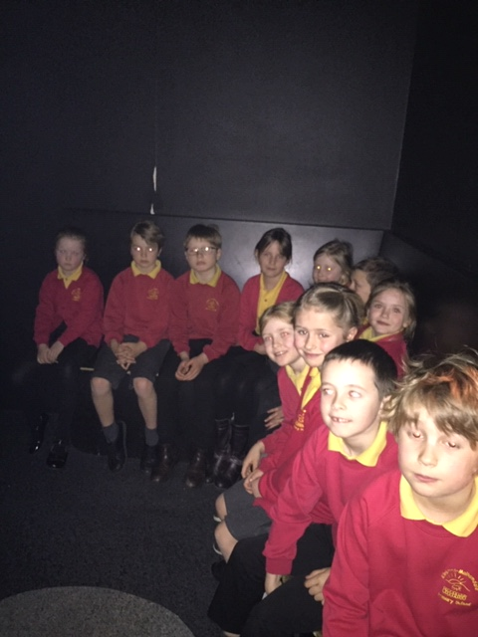
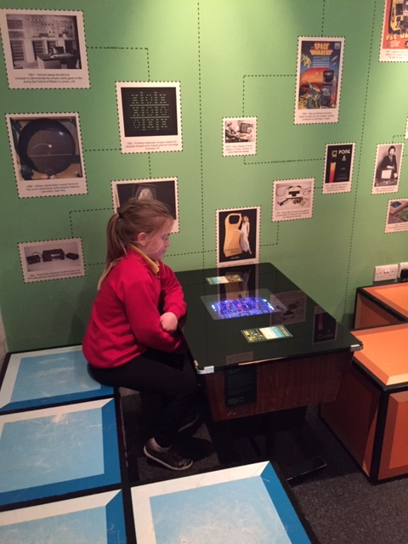

Crucial Crew - Y6 enjoyed the annual Crucial Crew event at Eshton Grange which was a fun packed day to enhance their PHSE education. They learnt about drug awareness, keeping safe and internet safety to name a few. They took part in lots of roll play scenario’s which I’m sure they will have told you about.

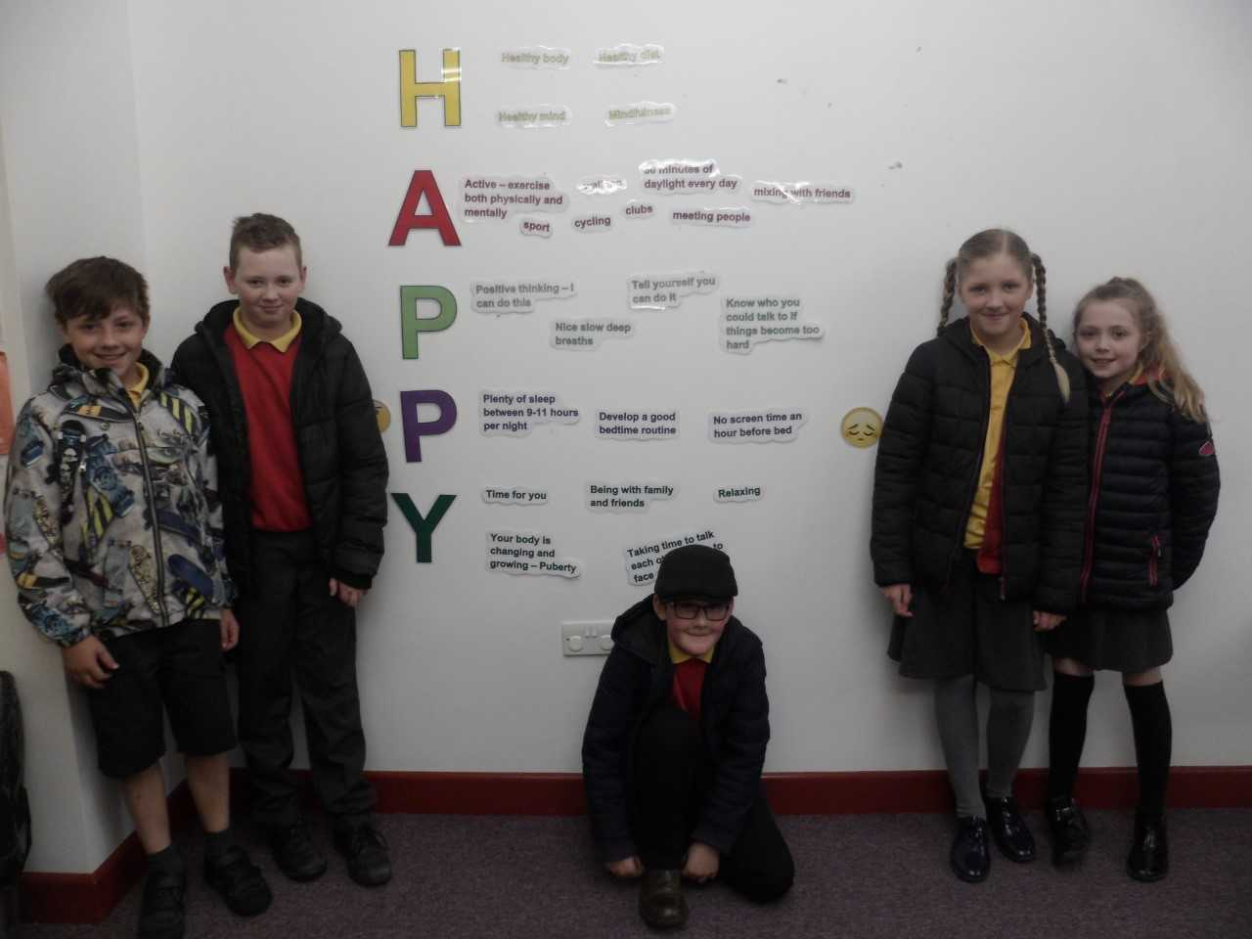
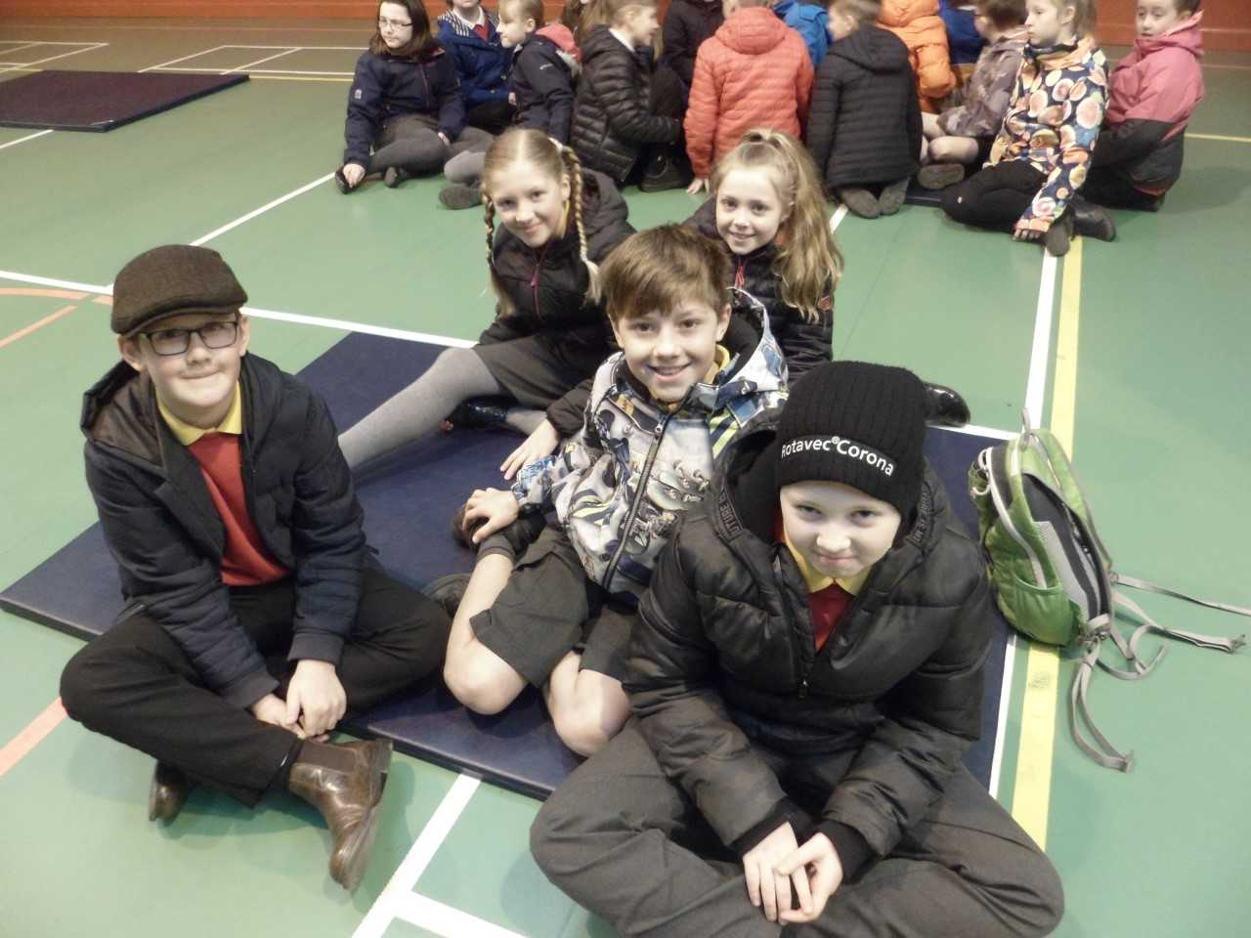

Falcon Visit - Thomas Smith writes.......
Ben’s dad came to school. He brought a Barn Owl and an Eagle Owl to show us. The Barn Owl flew but the Eagle Owl didn’t fly.
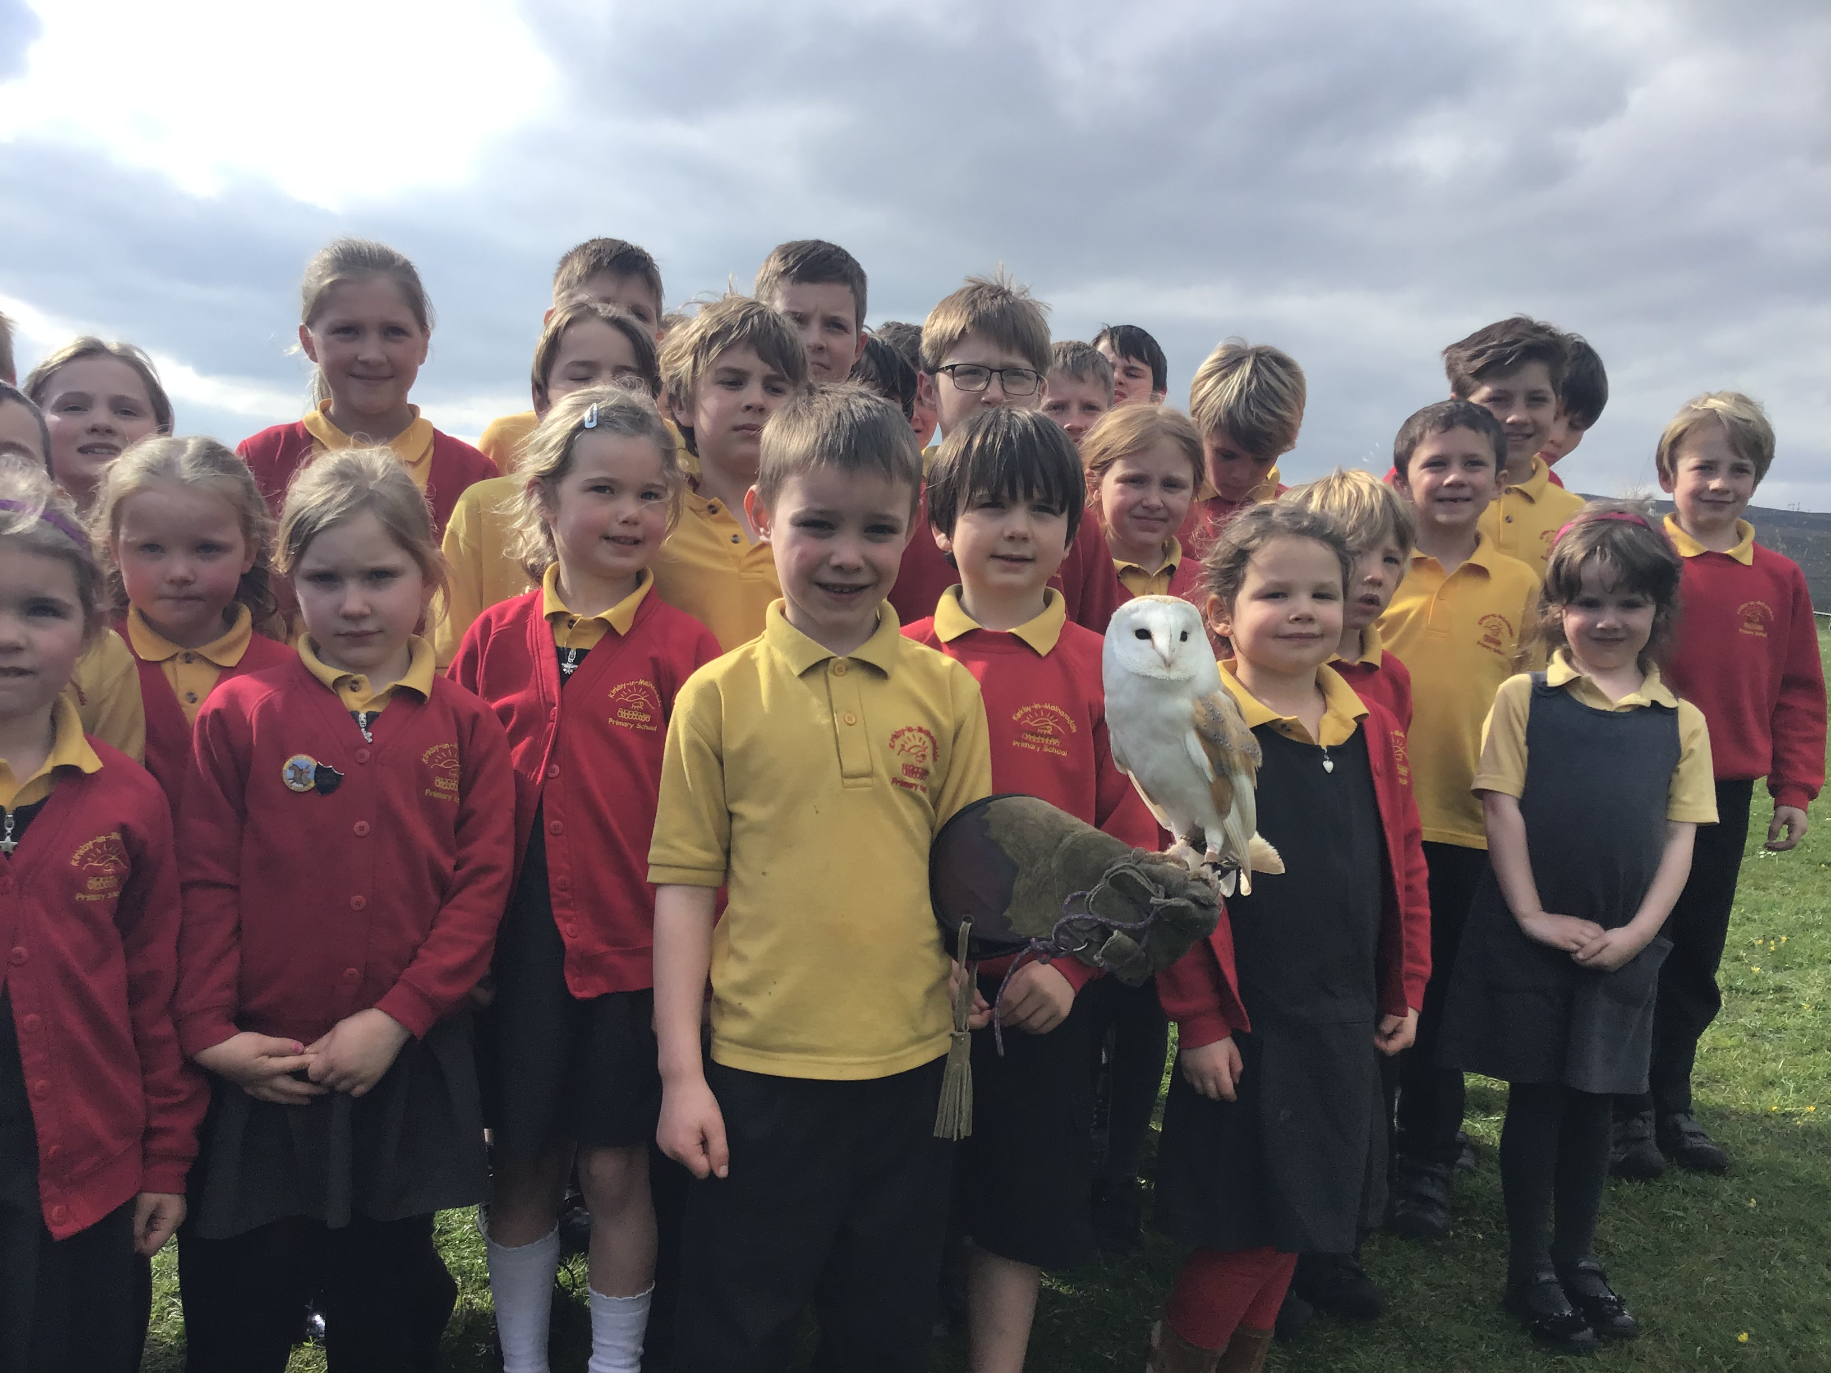
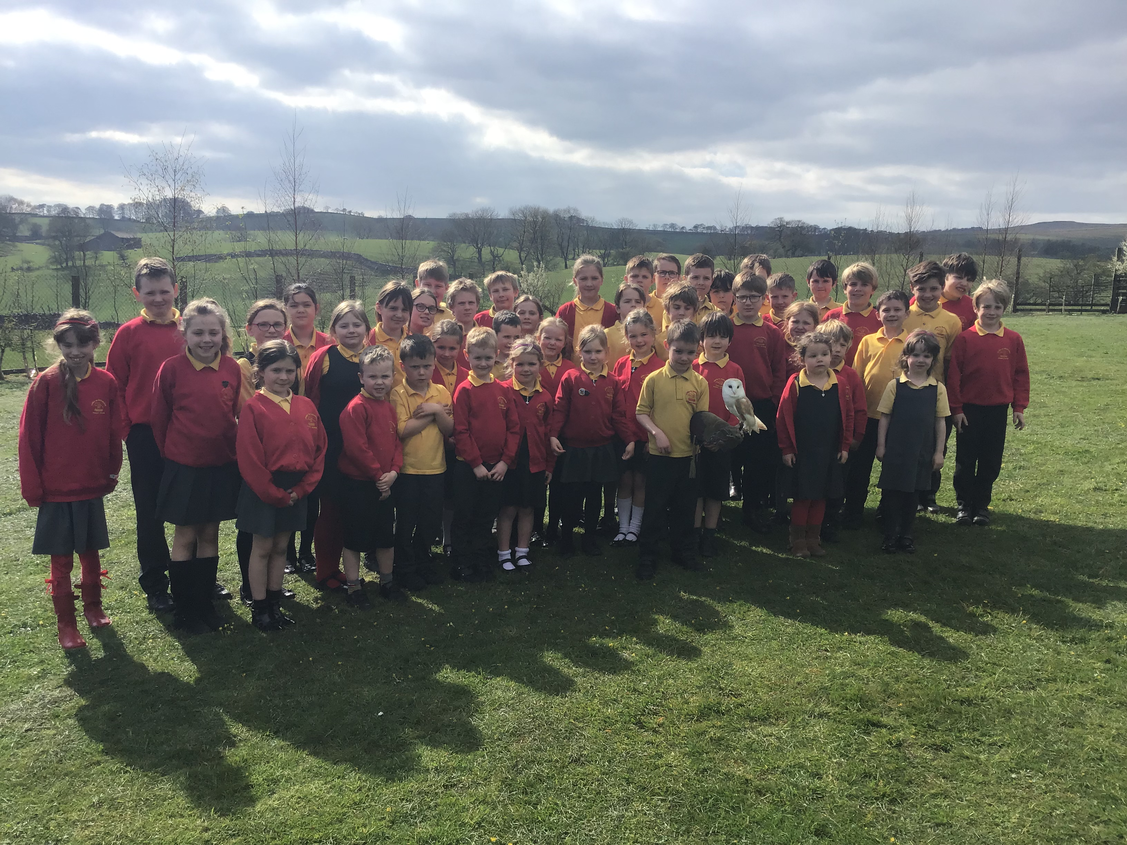

School Council We have looked at suggestions which people have put in the school suggestion box. Lots of people suggested a fun day and picnic. We felt this was a great idea and have written a persuasive letter to Mr Wright asking for permission to have a fun day in the summer term. We are hoping to plan a fantastic day for all our school including a picnic lunch. We await Mr Wright’s response.
The school council have written a newsletter so everyone knows what the school council is doing to make our school an even better place.
Happy Easter
Message from the Malham Safari Committee – As the school massively benefits from the donation from the Malhamdale Safari, the organisers need a little more support from children and parents during Safari week from Saturday 25th to Wednesday 29th May. If you are available to help with selling quiz sheets (parents please note children will need supervising) please can you contact Jill Heseltine on jill_hes@yahoo.co.uk. School is also running the Tea Room at Malham Village Hall on Sunday 26th May and if anyone can volunteer 2 hours to help in the café or by making cakes, buns or biscuits, please contact Victoria Forrow on victoria@forrow.com
Illness – Hopefully all the recent bugs will have disappeared over the Easter holidays but please do not send your child/children to school if they are unwell. Please read the policy on our website regarding what we can administer prescription wise and if your child has sickness or diarrhoea, please keep them off for 48 hours after the last episode.
A move toward Formal Federation - In the coming days, the school will be undertaking a public consultation on plans to formally Federate with Settle CE Primary School. At present we are in formal collaboration. This partnership has worked very well for both schools. Indeed, Ofsted believes it has already brought significant strengths to school leadership and overall provision. If we federate then our partnership will allow us to work in closer partnership with just one governing body representing both schools. The consultation process will last six weeks and will include parent meetings at both schools. These meetings will take place after the Easter break.
ParentPay - Please keep checking your ParentPay accounts and settle any outstanding debts. Please pay these as soon as possible – thank you. ParentPay alerts can be set up on https://www.parentpay.com/DOCH/school-support/wp-content/uploads/2018/05/How-to-set-up-alerts.pdf
Nursery Provision – We are excited that a new Nursery provision will be piloted from September 2019 and invite any prospective parents to add their child to the list for September and beyond. There will be a post-Easter parents meeting regarding this provision and how it will be implemented in the school. Please spread the word to interested families.
Start of the School Day – Please be aware that school does not open until 9.00 am every morning but you may arrive from 8.45am. Children dropped off before this time are the parents responsibility until a member of staff is on the playground at 8.45 am. Please can parents leave their children at the little gate into the playground for them to enter the entrance door by Class 2. If parents need to talk to the office or a member of staff they may come in through office door once they have seen their children through the little gate – many thanks.

Parking – Thank you for your continued help with this at the start and end of the day. The bus needs to get as close to the gate as possible to drop and collect the children safely. You may have noticed that the field adjoining the playground has been turned in to a car park for those busy times at school. This is not only to allow the bus access to the school but assist parents in parking off the road. Please use this area to park in if the gate is open.
School Uniform – We still have unnamed or incorrectly named uniform being worn by the children in school. Please name your children’s clothes, especially jumpers and cardigans (also swim wear too). All unnamed clothing is put in the lost property box in the corridor.
NUT FREE SCHOOL – Please be aware that we are a nut free school. Snacks that children in KS2 bring into school must only be fruit and vegetables, no cereal bars etc. Also, any cardboard for junk modelling should not be from a food source – no cereal boxes etc. Many thanks for your help with this.
This also means no other foodstuff e.g. Birthday cakes, sweets, crisps etc. We take our safeguarding extremely seriously and we thank you for your cooperation with this.
Book Club Class 1 – Book Club is going well and thank you for your support. Please feel free to come on Mondays from 3.00pm. Please sign in at reception – thank you.
Governors– Please look on our school website on the Governor section to familiarise yourselves with our school's Governing Body.

Headteacher Contact - If anyone would like to contact Mr Wright please do so at
headteacher@settle-pri.n-yorks.sch.uk
DIARY DATES
Fri 12th April | End of Spring Term
Tues 30th April | 9.00 am School Opens for the Summer term  1.00 – 3.00 pm Y3/4 Tennis at Skipton Tennis Club – letters gone out to children involved
Wed 1st May | 1 – 3 pm Dance Competition at Greatwood Primary School – details to follow
Thurs 2nd May | Tag Rugby Sessions start weekly with Hedley Verity for Y3,4,5 & 6
Fri 3rd May | 2.00 pm Consultation Meeting with parents and governors
Fri 3rd May | School closes for May Day holiday
Tues 5th May | School opens 9.00 am  Reception/Y6 Height and Weight with School Nurse
Wed 8th May | 9.30 am Year 3/5 Tri-Golf at Settle Cricket Club – letter sent
Mon 13th May | SATs Week Y6
Fri 24th May | 10.30 am Class 3 Brownlee Triathlon at Bradford Grammar School – letter to follow  3.30 pm School closes for half term
Mon 3rd June | 9.00 am School Opens
Tues 4th June | 9.30 – 11.30 am Cricket training for whole school starts weekly with Anthony Bradley
Thurs 6th June | Last Rugby Training with Hedley
Mon 10th June | Y1 Phonics Screening Week
Tues 11th June | Y6 from both Settle and KM to Eshton Grange for the day
Wed 12th June | Whole School to Eshton Grange for the day
Fri 14th June | 1-3pm Y5/6 Tag Rugby Tournament at Wharfedale
Thurs 20th June | Pm – Sports Day (weather permitting)
Fri 21st June | Reserve Sports Day
Mon 24th June | Tempest Photographers – Whole school and Y6 Leavers photos
Thurs 27th June | 1 – 3 pm Y3/4 Tag Rugby Tournament at Wharfedale
Wed 17th July | Whole school to Victoria Hall, Settle for day and evening performance at 6.30 pm
Fri 19th July | Adam Cox to deliver Tennis for whole school in the morning  End of term leavers Assembly (time to be advised)  3.30pm End of Summer Term

School Uniform – We have been informed by our suppliers MC Sports that uniform is available to order online at http://www.mcsports.org.uk/kirkby-malham-primary-school/
You can also ring Mike on 01756 791688 or email him at mcsportsonline@gmail.com

GDPR – Privacy Notice for Parents and Pupils
The latest Privacy Notice for Parents and Pupils can be seen on our school’s website under Statutory Information

Safeguarding Notice
Kirkby-in-Malhamdale United V.A Primary School is committed to ensuring the welfare and safety of all children in school. All North Yorkshire schools, including Kirkby-in-Malhamdale Primary School, follow the North Yorkshire Safeguarding Children Board procedures. The school will, in most circumstances, endeavour to discuss all concerns with parents about their child/ren. However, there may be exceptional circumstances when the school will discuss concerns with Social Care and/or the Police without parental knowledge (in accordance with Child Protection procedures). The school will, of course always aim to maintain a positive relationship with all parents. The school’s child protection policy is available in the policies section of the web site.

