Kirkby-in-Malhamdale United (VA) Primary School,

Kirkby Malham,

Skipton,

North Yorkshire,

BD23 4BY.

Telephone and Fax: 01729 830214
e-mail:admin@kim.n-yorks.sch.uk

Executive Headteacher: Mr Richard Wright

NEWSLETTER 14 Spring Term w/c 07/05/19

The last two week’s Captain’s Table were as follows:
12.04.19 Lucy, Hallam, Ben P. Connie, Alice, Sophie, Rafe, Preston, Ruby
03.05.19 William S, Edward S, Ruby, Vincent, Tyler, Thomas, Oliver, James, Charlotte
Congratulations to everyone mentioned above and keep up the good work.
SPORTING EVENTS
Y3/4 Tennis at Skipton Tennis Club-Charlotte writes ‘Y3 and Y4 went to tennis and we had a lovely time. There were 5 matches and each of us did well. There were lots of schools there playing. We were able to use the skills we had learnt in our lessons with Adam as well’.

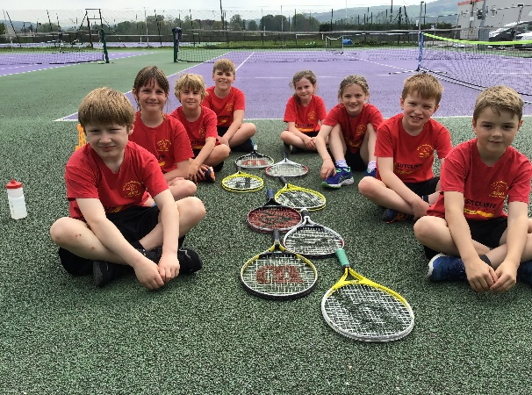

Dance Competition at Greatwood School-Flynn writes ’11 boys went to Greatwood School. We all danced our hardest and we all had fun. We danced to Take That’s song ‘Everlasting’. The other schools danced well but we think we were the best.’
Tri-Golf at Settle Cricket Club-Harry E writes ‘On the 8th May all Y3 and Y4 went for a Golf Competition. There were 8 stages and they were hard. Y3 were the B team and Y4 were the A team. The weather was bad but we had lots of fun. Thank you Mrs Allen’.

Proposal to Federate
Consultation continues on the proposal for the formal federation of Kirkby Malham Primary with Settle Primary. Parent meetings have taken place at both schools and together with returned feedback sheets, a decision will be made as to next steps through a joint school governing body meeting. Parents will be informed of the decision after the half term break.
New Nursery
Details for the new pilot Nursery setting are being formed and finalised. There will be a meeting on Friday 24th May at 2.30 pm when Mr Wright and Mrs Middleton will be able to talk through plans and answer any questions.
School Council – The School Council are busily planning a ‘Fun Day’ this term for everyone at school. Further details will be announced as plans progress.
Malham Safari – 25th – 29th May – School is running the Café at Malham Village Hall on Sunday 26th May. Please contact Victoria Forrow if you can help for 2 hours during that day or alternatively homemde cakes, buns and biscuits would be gratefully received that morning in the village hall. (victoria@forrow.com)
Illness – Please do not send your child/children to school if they are unwell. Please read the policy on our website regarding what we can administer prescription wise and if your child has sickness or diarrhoea, please keep them off for 48 hours after the last episode.
ParentPay - Please keep checking your ParentPay accounts and settle any outstanding debts. Please pay these as soon as possible – thank you. ParentPay alerts can be set up on https://www.parentpay.com/DOCH/school-support/wp-content/uploads/2018/05/How-to-set-up-alerts.pdf
Start of the School Day – Please be aware that school does not open until 9.00 am every morning but you may arrive from 8.45am. Children dropped off before this time are the parents responsibility until a member of staff is on the playground at 8.45 am. Please can parents leave their children at the little gate into the playground for them to enter the entrance door by Class 2. If parents need to talk to the office or a member of staff they may come in through office door once they have seen their children through the little gate – many thanks.
Parking – Thank you for your continued help with this at the start and end of the day. The bus needs to get as close to the gate as possible to drop and collect the children safely. You may have noticed that the field adjoining the playground has been turned in to a car park for those busy times at school. This is not only to allow the bus access to the school but assist parents in parking off the road. Please use this area to park in if the gate is open.
School Uniform – We still have unnamed or incorrectly named uniform being worn by the children in school. Please name your children’s clothes, especially jumpers and cardigans (also swim wear too). All unnamed clothing is put in the lost property box in the corridor.
NUT FREE SCHOOL – Please be aware that we are a nut free school. Snacks that children in KS2 bring into school must only be fruit and vegetables, no cereal bars etc. Also, any cardboard for junk modelling should not be from a food source – no cereal boxes etc. Many thanks for your help with this.
This also means no other foodstuff e.g. Birthday cakes, sweets, crisps etc. We take our safeguarding extremely seriously and we thank you for your cooperation with this.
Book Club Class 1 – Book Club is going well and thank you for your support. Please feel free to come on Mondays from 3.00pm. Please sign in at reception – thank you.
Governors– Please look on our school website on the Governor section to familiarise yourselves with our school's Governing Body.

Headteacher Contact - If anyone would like to contact Mr Wright please do so at
headteacher@settle-pri.n-yorks.sch.uk
DIARY DATES
Fri 10th May | 2.45 pm Celebration Assembly
Mon 13th May | SATs Week Y6
Mon 20th May | Pm Dougie Lampkin talk with whole school
Fri 24th May | 10.30 am Class 3 Brownlee Triathlon at Bradford Grammar School – letter to follow  2.30 pm Nursery Meeting for Parents with Mr Wright and Mrs Middleton  3.30 pm School closes for half term
Mon 3rd June | 9.00 am School Opens
Tues 4th June | 9.30 – 11.30 am Cricket training for whole school starts weekly with Anthony Bradley
Thurs 6th June | Last Rugby Training with Hedley
Mon 10th June | Y1 Phonics Screening Week
Tues 11th June | Y6 from both Settle and KM to Eshton Grange for the day
Wed 12th June | Whole School to Eshton Grange for the day
Fri 14th June | 1-3pm Y5/6 Tag Rugby Tournament at Wharfedale
Tues 18th June | 1.00pm Y5/6 Tennis Competition at Skipton Tennis Centre – details to follow
Wed 19th June | Whole school to Ilkley Tennis Club for workshop and watch professionals
Thurs 20th June | Pm – Sports Day (weather permitting)
Fri 21st June | Reserve Sports Day
Mon 24th June | Tempest Photographers – Whole school and Y6 Leavers photos
Thurs 27th June | 1 – 3 pm Y3/4 Tag Rugby Tournament at Wharfedale  1.30 – 3.30pm Foundation Transition – details to follow
Wed 3rd July | 2-3 pm Early Years Information Meeting with Mrs Middleton – details to follow
Thurs 4th July | Transition Day – Foundation lunch and afternoon/Nursery afternoon only – details to follow
Mon 8th July | 1.30 pm PSHE/Puberty Talk for Y6
Thurs 11th July | Transition Session – Foundation all day and Nursery for the afternoon – details to follow
Wed 17th July | Whole school to Victoria Hall, Settle for day and evening performance at 6.30 pm
Fri 19th July | Adam Cox to deliver Tennis for whole school in the morning  End of term leavers Assembly (time to be advised)  3.30pm End of Summer Term

School Uniform – We have been informed by our suppliers MC Sports that uniform is available to order online at http://www.mcsports.org.uk/kirkby-malham-primary-school/
You can also ring Mike on 01756 791688 or email him at mcsportsonline@gmail.com

GDPR – Privacy Notice for Parents and Pupils
The latest Privacy Notice for Parents and Pupils can be seen on our school’s website under Statutory Information

Safeguarding Notice
Kirkby-in-Malhamdale United V.A Primary School is committed to ensuring the welfare and safety of all children in school. All North Yorkshire schools, including Kirkby-in-Malhamdale Primary School, follow the North Yorkshire Safeguarding Children Board procedures. The school will, in most circumstances, endeavour to discuss all concerns with parents about their child/ren. However, there may be exceptional circumstances when the school will discuss concerns with Social Care and/or the Police without parental knowledge (in accordance with Child Protection procedures). The school will, of course always aim to maintain a positive relationship with all parents. The school’s child protection policy is available in the policies section of the web site.

