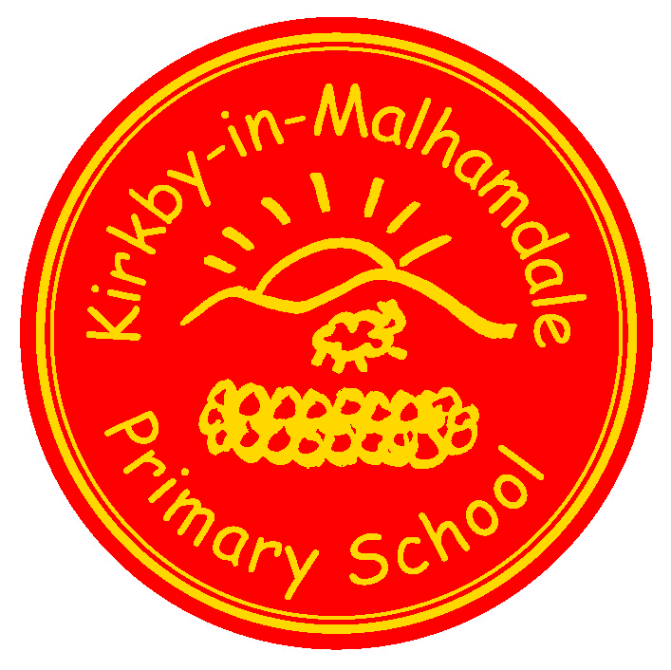
Kirkby-in-Malhamdale United (VA) Primary School,

Kirkby Malham,

Skipton,

North Yorkshire,

BD23 4BY.

Telephone and Fax: 01729 830214
e-mail:admin@kim.n-yorks.sch.uk

Executive Headteacher: Mr Richard Wright

NEWSLETTER 15 Spring Term w/c 20.05.19

The last two week’s Captain’s Table were as follows:
10/05/19 Thomas C, Ben P, Ben B, Alice, Elliot, Hallam, Victoria, Charlie, Harry E
17/05/19 Fraiser, Harry H, Violet, Victoria, Katy, Carys, Joshua W, Alfie
KiM Awards to: Violet (Class 1), Harry H (Class 2), Victoria (Class 3)
Congratulations to everyone mentioned above and keep up the good work
Proposal to Federate
Consultation continues on the proposal for the formal federation of Kirkby Malham Primary with Settle Primary. Parent meetings have taken place at both schools and together with returned feedback sheets, a decision will be made as to next steps through a joint school governing body meeting. Parents will be informed of the decision after the half term break.
New Pre-School Nursery
Details for the new pilot Nursery setting are being formed and finalised. There will be a meeting on Friday 24th May at 2.30 pm when Mr Wright and Mrs Middleton will be able to talk through plans and answer any questions.
Class 1 are very much looking forward to welcoming our September starters to school after half term when they join us for their taster sessions. We are particularly excited to welcome Nursery children for the first time, as from September we will be offering provision to 3 and 4 year old pre-schoolers. Exciting times for our school!
Please spread the word about our Nursery and make families you know with young children aware of our new provision at the school. Visits are very welcome and can be arranged by contacting the school office. Thanks for your support.
School Council –
School Council are busy planning and preparing a fun day for the whole school to take place on Friday 12th July. The
council are working on an exciting themed event! Further details after half term.
Malham Safari – 25th – 29th May – School is running the Café at Malham Village Hall on Sunday 26th May. Any homemade cakes, buns and biscuits would be gratefully received that morning in the village hall.
After School Club – The After School Clubs will run as normal after half term from Monday to Thursday. If your child is already on the register you need do nothing but if you want your child to join either Construction/French Club on Monday, Baking Betty on Tuesday (both until 6pm with tea) or Howards Dance Club on Thursday (until 4.30pm, no tea), please do not hesitate to contact the school office.
SPORTS DAY DATE CHANGE Please note that Sports Day is now on FRIDAY 21ST JUNE
Y6/Y5 Bikeability Training Course – 1st & 2nd July. The children are taking part in a NYCC accredited scheme lead by qualified Bikeability instructors which will include children learning to ride, under supervision, on public roads. The roads will be risk assessed by our local Road Safety Officer prior to the training. The children will need a roadworthy bike in good working order plus a helmet – more details will be sent after half term.
Illness – Please do not send your child/children to school if they are unwell. Please read the policy on our website regarding what we can administer prescription wise and if your child has sickness or diarrhoea, please keep them off for 48 hours after the last episode.
ParentPay - Please keep checking your ParentPay accounts and settle any outstanding debts. Please pay these as soon as possible – thank you. ParentPay alerts can be set up on https://www.parentpay.com/DOCH/school-support/wp-content/uploads/2018/05/How-to-set-up-alerts.pdf
Start of the School Day – Please be aware that school does not open until 9.00 am every morning but you may arrive from 8.45am. Children dropped off before this time are the parents responsibility until a member of staff is on the playground at 8.45 am. Please can parents leave their children at the little gate into the playground for them to enter the entrance door by Class 2. If parents need to talk to the office or a member of staff they may come in through office door once they have seen their children through the little gate – many thanks.
Parking – Thank you for your continued help with this at the start and end of the day. The bus needs to get as close to the gate as possible to drop and collect the children safely. You may have noticed that the field adjoining the playground has been turned in to a car park for those busy times at school. This is not only to allow the bus access to the school but assist parents in parking off the road. Please use this area to park in if the gate is open.
School Uniform – We still have unnamed or incorrectly named uniform being worn by the children in school. Please name your children’s clothes, especially jumpers and cardigans (also swim wear too). All unnamed clothing is put in the lost property box in the corridor.
NUT FREE SCHOOL – Please be aware that we are a nut free school. Snacks that children in KS2 bring into school must only be fruit and vegetables, no cereal bars etc. Also, any cardboard for junk modelling should not be from a food source – no cereal boxes etc. Many thanks for your help with this.
This also means no other foodstuff e.g. Birthday cakes, sweets, crisps etc. We take our safeguarding extremely seriously and we thank you for your cooperation with this.
Book Club Class 1 – Book Club is going well and thank you for your support. Please feel free to come on Mondays from 3.00pm. Please sign in at reception – thank you.
Governors– Please look on our school website on the Governor section to familiarise yourselves with our school's Governing Body.
School Uniform – http://www.mcsports.org.uk/kirkby-malham-primary-school/ mcsportsonline@gmail.com
Headteacher Contact - If anyone would like to contact Mr Wright please do so at
headteacher@settle-pri.n-yorks.sch.uk
DIARY DATES
Fri 24th May | 10.30 am Class 3 Brownlee Triathlon at Bradford Grammar School – letter to follow  2.30 pm Nursery Meeting for Parents with Mr Wright and Mrs Middleton  3.30 pm School closes for half term
Mon 3rd June | 9.00 am School Opens
Tues 4th June | 9.30 – 11.30 am Cricket training for whole school starts weekly with Anthony Bradley
Thurs 6th June | Last Rugby Training with Hedley
Mon 10th June | Y1 Phonics Screening Week
Tues 11th June | Y6 from both Settle and KM to Eshton Grange for the day  Y2 Mini Olympics at Settle Playing Fields
Wed 12th June | Whole School to Eshton Grange for the day
Thurs 13th June | Pm Dougie Lampkin Presentation for whole school
Fri 14th June | 1-3pm Y5/6 Tag Rugby Tournament at Wharfedale
Tues 18th June | 1.00pm Y5/6 Tennis Competition at Skipton Tennis Centre – details to follow
Wed 19th June | Whole school to Ilkley Tennis Club for workshop and watch professionals
Fri 21st June | Pm Sports Day (New Date)
Mon 24th June | Tempest Photographers – Whole school and Y6 Leavers photos
Thurs 27th June | 1 – 3 pm Y3/4 Tag Rugby Tournament at Wharfedale  1.30 – 3.30pm Foundation Transition
Mon & Tues 1st & 2nd July | Y6/5 NYCC Bikeability Training – details to follow
Wed 3rd July | 2-3 pm Early Years Information Meeting with Mrs Middleton
Thurs 4th July | Transition Day – Foundation lunch and afternoon/Nursery afternoon only
Mon 8th July | 1.30 pm PSHE/Puberty Talk for Y6
Thurs 11th July | Transition Session – Foundation all day and Nursery for the afternoon
Fri 12th July | School Council Fun Day – details to follow
Wed 17th July | Whole school to Victoria Hall, Settle for day and evening performance at 6.30 pm
Fri 19th July | End of term leavers Assembly (time to be advised)  3.30pm End of Summer Term

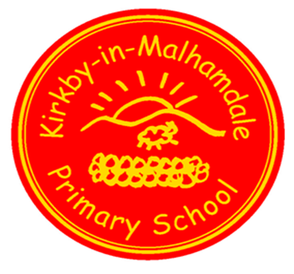

Early Years Foundation Stage

Free Nursery Pre-School provision for
3 and 4 year olds
We offer high quality teacher-led Nursery Pre-School provision.
If you would like to find out more, please contact our school office on
01729 830214 or email
admin@kim.n-yorks.sch.uk
Come and see our brilliant outdoor provision including Forest School activities.
We look forward to meeting you!

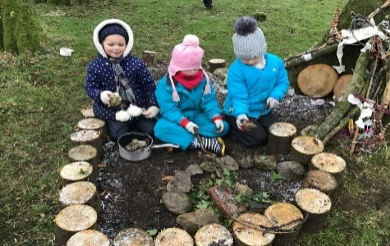
Follow us on Facebook

GDPR – Privacy Notice for Parents and Pupils

The latest Privacy Notice for Parents and Pupils can be seen on our school’s website under Statutory Information

Safeguarding Notice
Kirkby-in-Malhamdale United V.A Primary School is committed to ensuring the welfare and safety of all children in school. All North Yorkshire schools, including Kirkby-in-Malhamdale Primary School, follow the North Yorkshire Safeguarding Children Board procedures. The school will, in most circumstances, endeavour to discuss all concerns with parents about their child/ren. However, there may be exceptional circumstances when the school will discuss concerns with Social Care and/or the Police without parental knowledge (in accordance with Child Protection procedures). The school will, of course always aim to maintain a positive relationship with all parents. The school’s child protection policy is available in the policies section of the web site.

